Science and Technology 404
Review Notes
Periodic Table
- Groups(families) and Periods
- Groups are vertical columns
- Members of the same group have the same number of valence electrons and therefore have similar chemical properties.
- Group IA: Alkali metals (soft metals, very chemically reactive, tend to lose one electron)
1 valence electron
- Group IIA: Alkaline Earth metals (found in rocks or earth, not as chemically reactive as alkali metals, tend to lose two electrons)
2 valence electrons
- Group VIIA: Halogens (very reactive nonmetals, used as disinfectants, tend to gain one electron)
7 valence electrons
- Group VIIIA: Inert gases (not chemically reactive, tend not to gain or lose any electrons because they have a full last shell)
8 valence electrons
- Periods are horizontal rows
- Members of the same period have the same number of shells
Period 1 = one shell
Period 2= two shells
Period 3= three shells
Period 4= four shells

- Drawing Bohr-Rutherford diagrams
- The atomic number tells you how many protons or electrons the atom has
- The protons are found in the nucleus
- The electrons are found in shells around the nucleus
- The first shell can hold two electrons
- The second shell can hold eight electrons
- The third shell can hold eight electrons
- The fourth shell can hold two electrons

Example: Write the symbol for the alkali metal in period 2, and represent this element using the Rutherford-Bohr model.

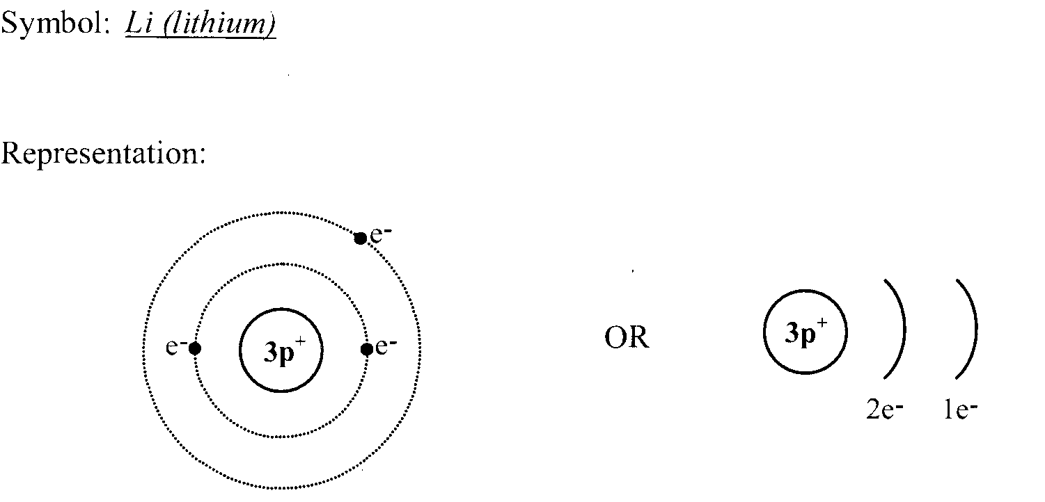
- Representing atoms using Lewis notation
- The dots represent the number of valence electrons
Example:

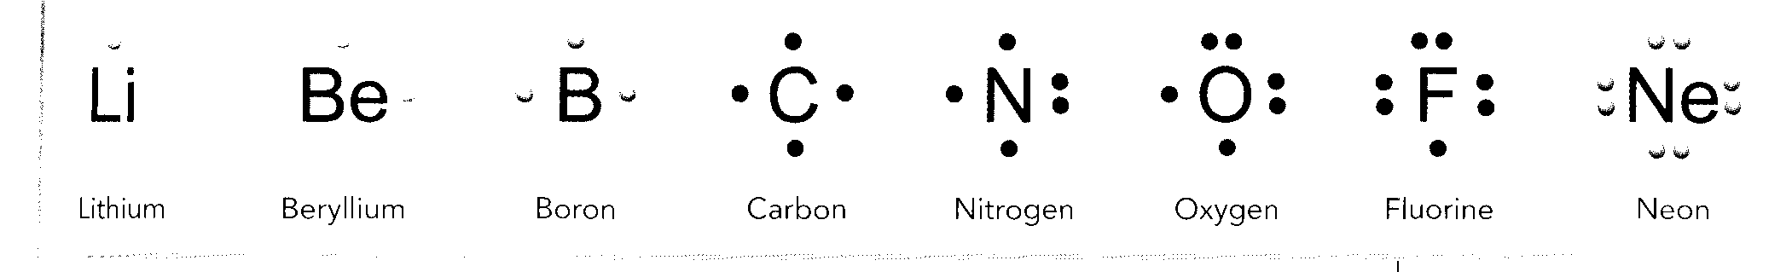

- Ions
- When an atom loses or gains electrons it becomes a charged atom. A charged atom is called an ion.
- Elements tend to acquire the configuration of the inert gas closest to them in the periodic table.

Example:
Calcium has 20 protons and 20 electrons. When it loses its two valence electrons, what charge does it have?

It becomes a positive ion with a charge of +2.

Chemical Changes

- Combustion
- Signs (heat and light)
- Fire triangle

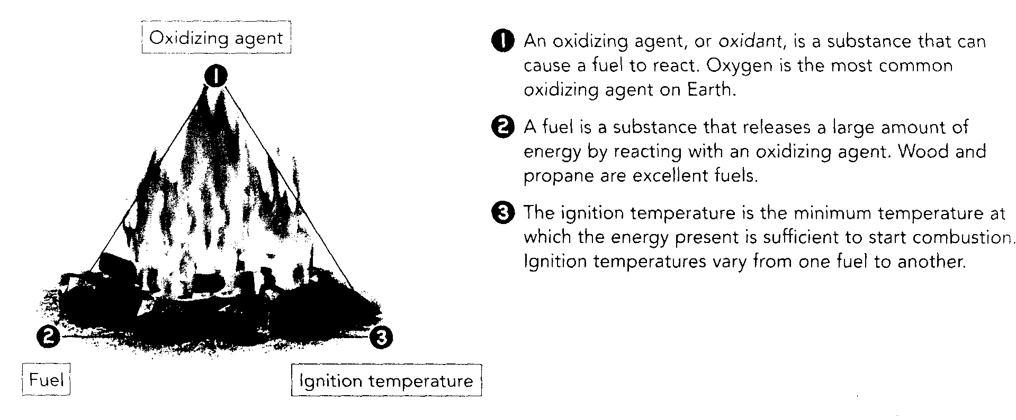

- Photosynthesis and respiration
- Producers carry out photosynthesis to make their own food
- Carbon dioxide + water +sunlight glucose (food) + oxygen
- Respiration takes place in the cells of most living organisms
- Glucose + oxygen carbon dioxide + water + energy
- The energy produced is used to keep the body warm and/or used to carry out tasks
- Acid-base neutralization
- Acids neutralize bases and bases neutralize acids
- Acid + base salt + water
- ex. “Liming” a lake means adding a base to lake water to decrease its acidity (increase its pH)
- Balancing chemical equations
- The number of each type of atom on each side of a chemical equation must remain constant.
Example: Balance the following equation: N₂ + H₂ NH₃

2N₂ + 3H₂ NH₃

Particle models
Example: Draw a particle model of the following chemical reaction. Use these symbols to represent the atoms.
Carbon Hydrogen Oxygen

CH₄ + 2O₂ CO₂ + 2H₂O

+ +

Conservation of mass
- The mass of the reactants equals the mass of the products.
Example:
Eight grams of methane (CH₄) is burned in 32 grams of oxygen (O₂) according to the following equation:

CH₄ + 2 O₂ CO₂ + 2 H₂O

Along with a certain quantity of water, 22 grams of carbon dioxide (CO₂) is obtained.
What is the mass of water obtained?

Mass of reactants = Mass of products
8g + 32g = 22g = ?
40 g = 40 g

40 g – 22g = 18 g
Electricity
- Electric charges
- Protons are positive,
- Electrons are negative

- Static electricity
- Transfer of electrons from one body to another
- Same charge repel each other
- Opposite charges attract each other

Example: Draw a diagram to illustrate what happens when a plastic ruler is rubbed with a cotton cloth. Assume that the ruler becomes negatively-charged.
Before rubbing | During rubbing | After rubbing
Both objects are neutral | Electrons are transferred from the cotton cloth to the ruler | Ruler is negatively-charged and cloth is positively-charged
- Ohm’s Law
As voltage increases, current intensity increases
Example: What is the resistance of a circuit element carrying a 3.5 A current at a potential difference of 55 V?
$$R =VI$$
$=$ 55V $×$ 3.5A
$=192.5 Ω$

- Difference between a series and parallel circuits
- A series circuit only has one path for electric current to flow.
- A parallel circuit branches at least once so electric current can follow different paths.
Circuit diagrams
Series circuit Parallel circuit 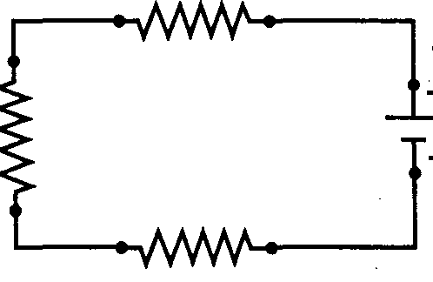 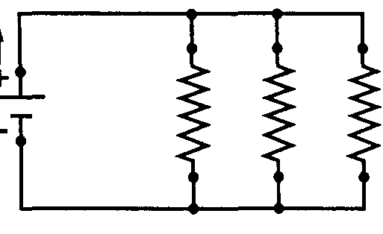

- Electrical functions (conduction, insulation, control, protection, power supply, transformation of energy)
- Conduction: a component that transmits electric current from one part of circuit to another (Ex. Copper wires)
- Insulation : a component that prevents electric current from flowing (ex. Rubber on the wire)
- Control: a component that can open and close a circuit (ex. Switch)
- Protection: a component that can automatically cut current flow in the event of an outage ( ex. fuse box or circuit breaker)
- Power supply: a component that generate an electric current (ex. Battery, generator, outlet etc. )
- Transformation of energy: a component that converts electrical energy into another form of energy (ex. Toaster, door bell, light bulb, etc.)

- Distinguish between a conductor and insulator in a technical object
- A conductor allows the flow of electric current through it (ex. Metals)
- An insulator does not allow the flow of electric current through it (ex. Rubber, ceramic)
- Types of switches (push button, toggle, magnetic, contact, rocker)
- Types of power supplies (chemical battery, solar cell, alternator, etc. )
- Alternating versus direct current
- In AC, the electrons move back and forth in a regular pattern
- In DC, the electrons are continuously moving in the same direction.
- The power (P) of an appliance depend on the voltage (V) and the current that it draws (I)
- P=VI
Example: What is the power of a motor whose rating plate indicates 110 V and 2.0 A?

P=VI
= 110V x 2.0A
$=$ 220W

- The electrical energy (E) consumption of a circuit or an appliance depends on its power (P) and the time that it is on (t)
- E =PΔ t (in Joules, W●h, kW●h)

Example: If a 100 W amplifier runs for four hours at full capacity, how much energy does it consume in 2 hours.

- in joules ?
P = 100W
t = 2 hours x 60 min/hour x 60 sec/min = 7200 seconds

E =PΔ t
= 100W x 7200 seconds
=720000 J or 720 kJ

- in W●h?

P = 100W
t = 2 hours

E =PΔ t
= 100W x 2 hours
=200 W∙h

c) in kW●h ?

P = 100W $÷$ 1000 = 0.1kW
t = 2 hours

E =PΔ t
= 0.1kW x 2 hours
=0.2kW∙h

- Different types of energy resources (hydroelectric plants, combustion of fossil fuels, geothermal plants, solar plants, tidal plants, wind turbines)
- Some energy resources are renewable, some are not.
- Hydroelectric plants (hydrosphere) use the kinetic energy of moving water to produce electricity (renewable).
- Combustion of fossil fuels (lithosphere) uses the combustion of oil, gas and coal to produce electricity (non-renewable).
- Geothermal plants(lithosphere) use the internal heat of the Earth to produce electricity (renewable)
- Solar plants (atmosphere) use the Sun’s rays to produce electricity.
- Tidal plants (hydrosphere) use the movement of the tides to produce electricity (renewable)
- Wind turbines (atmosphere) use the kinetic energy of the wind to produce electricity (renewable)

- Energy efficiency (proportion of energy consumed that is transformed into effective force)
Formula:

Energy Efficiency = Quantity of usable energy X 100
Quantity of energy consumed

Example: What is the energy efficiency of a 100 W light bulb that consumes 720 000 J of electrical energy and transforms 43 200 J into light?

Energy Efficiency = Quantity of usable energy X 100
Quantity of energy consumed

= 43 200 J x 100
720 000 J

= 6%
Magnetism
- Magnetic field around a permanent magnet.

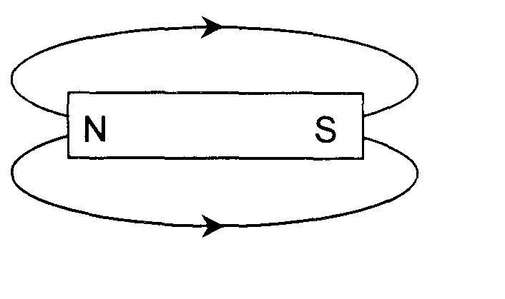

- Forces of attraction and repulsion between two magnets
- Opposite poles attract
- Like poles repel
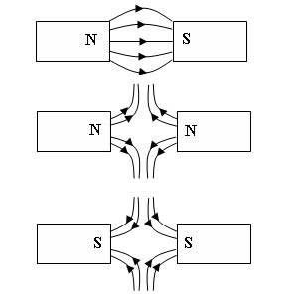
- Compasses
- A compass is a small magnet.

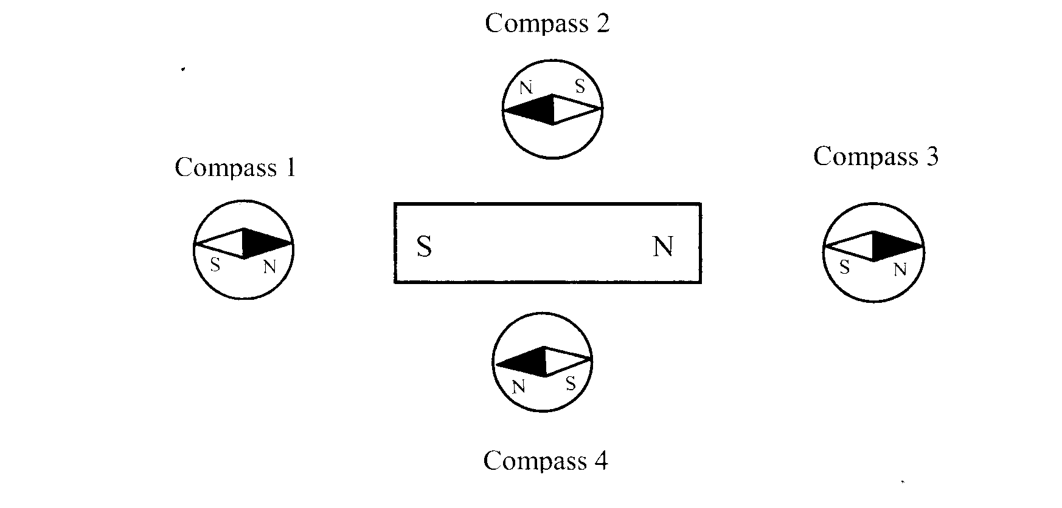

- Magnetic field around a live wire
- Right-hand rule: The thumb points in the conventional current direction (points to negative) and the fingers grasping the wire show the direction of the magnetic field lines.

Note: The North Pole of the compass always points in the same direction as the arrow.
Example 1: Example 2:
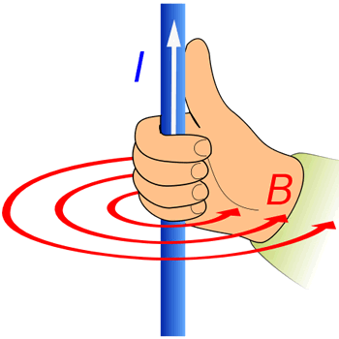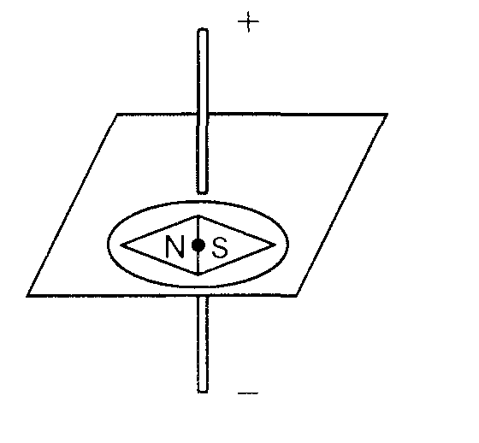

- Three ways of modifying the magnetic field produced by a live wire (type of wire, current intensity, and length of wire)

Mechanical engineering
- Describe the characteristics of links (direct or indirect, rigid or flexible, removable or permanent, partial or complete)
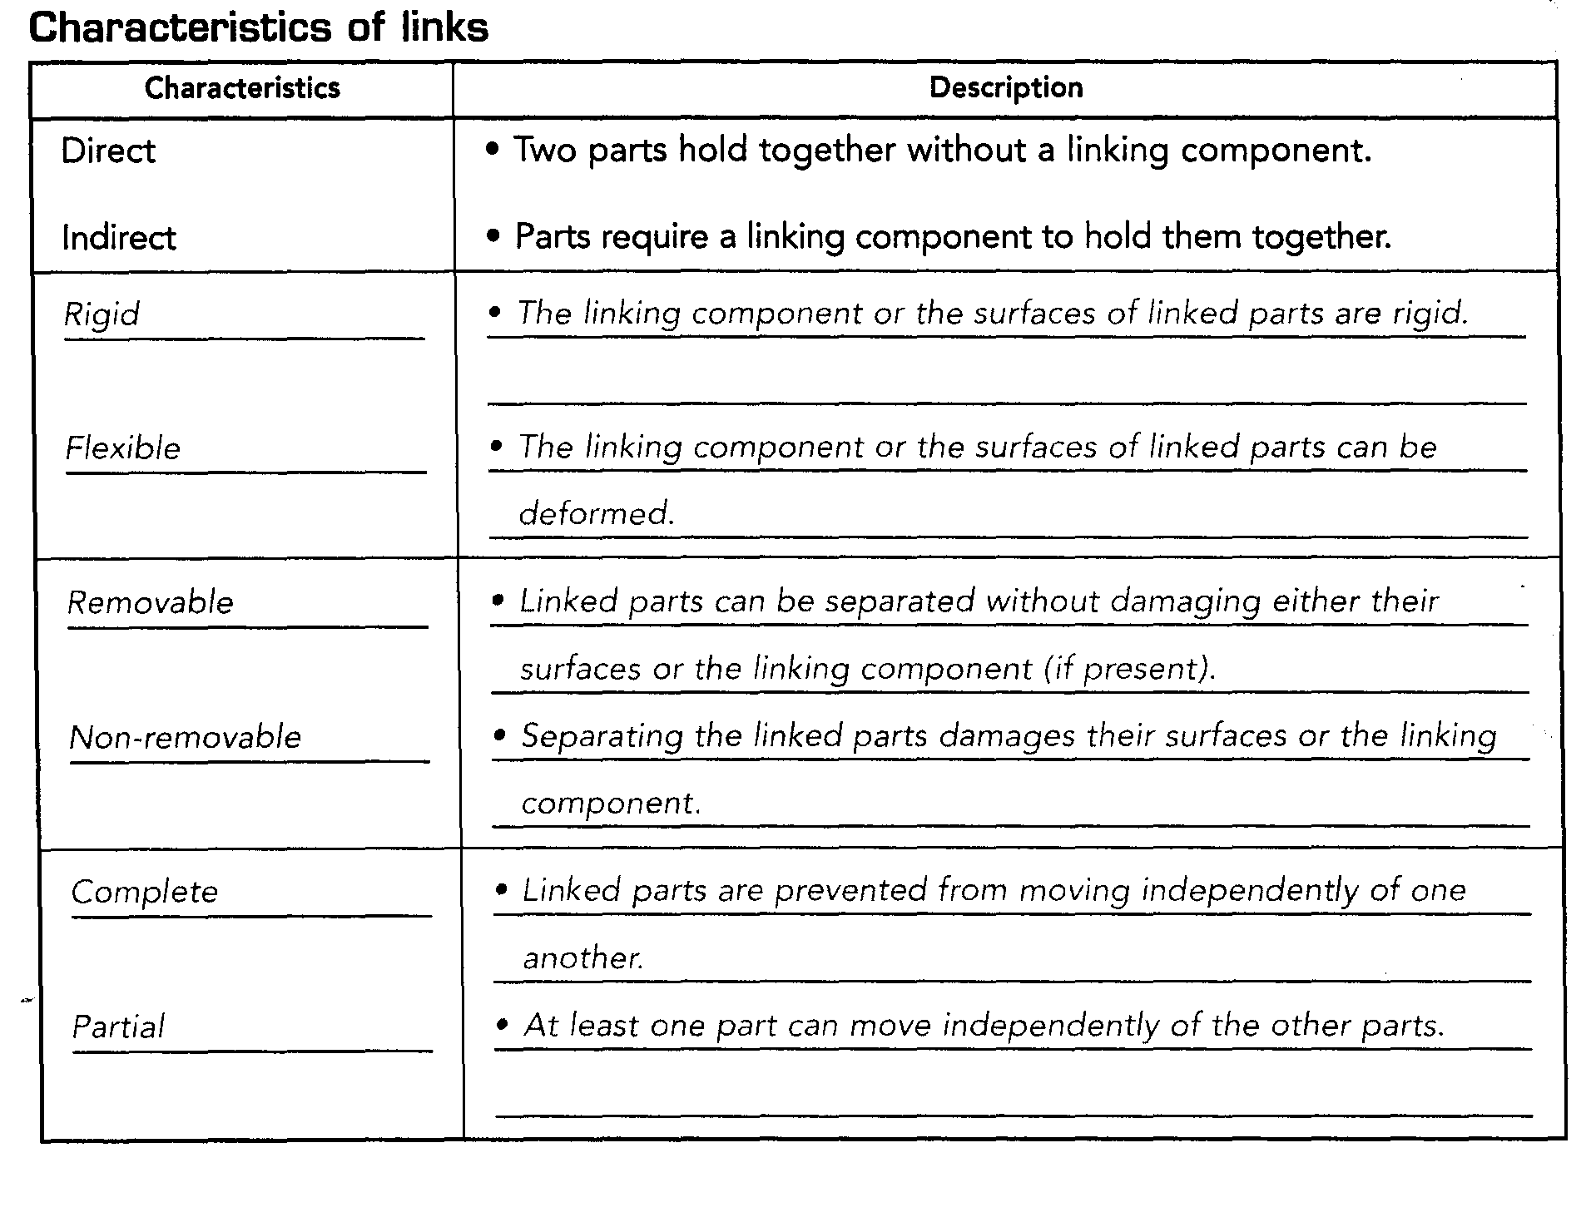
- Type of guiding (rotational, translational, helical)
- Rotational guiding ensures the rotational motion of a moving part
- Translational guiding ensures the straight motion of a moving part
- Helical guiding ensures the translational motion of a moving part while it rotates about the same axis.

- Types of guiding controls (what guides the moving parts)
For rotational guiding, the guiding control is usually a cylindrical part.
For translational guiding, the guiding control is usually a groove or a slide.
For helical guiding, the guiding control is usually a threaded component.

- Motion transmission systems (type of motion is not changed)
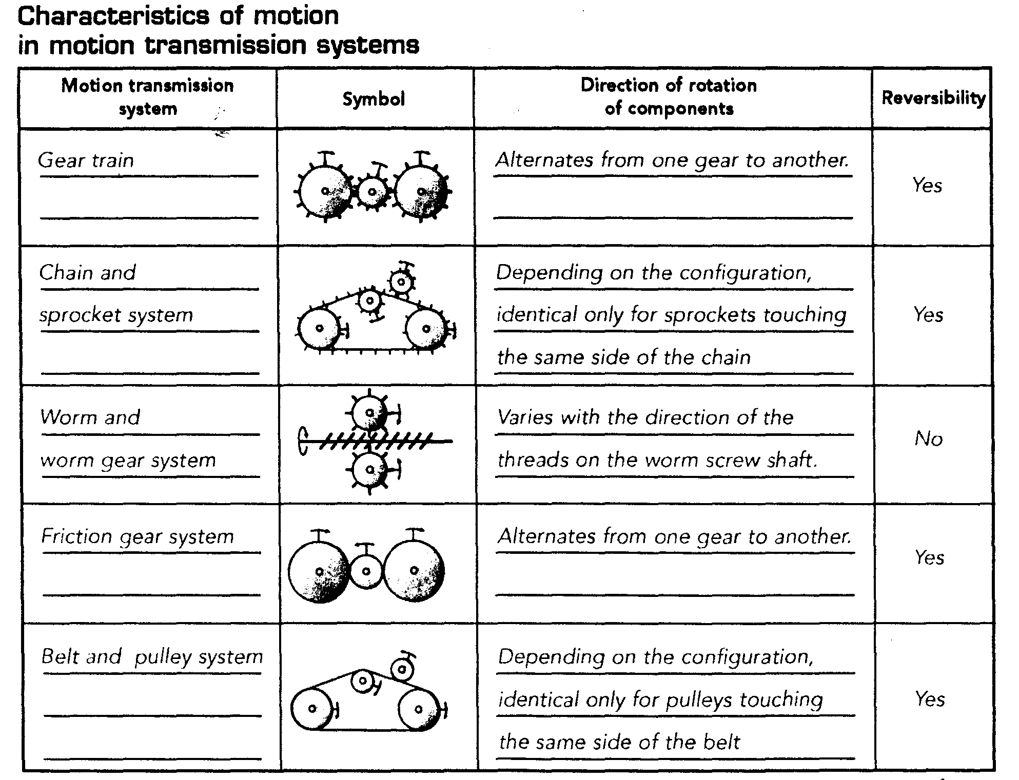
- Motion transformation (type of motion is changed)
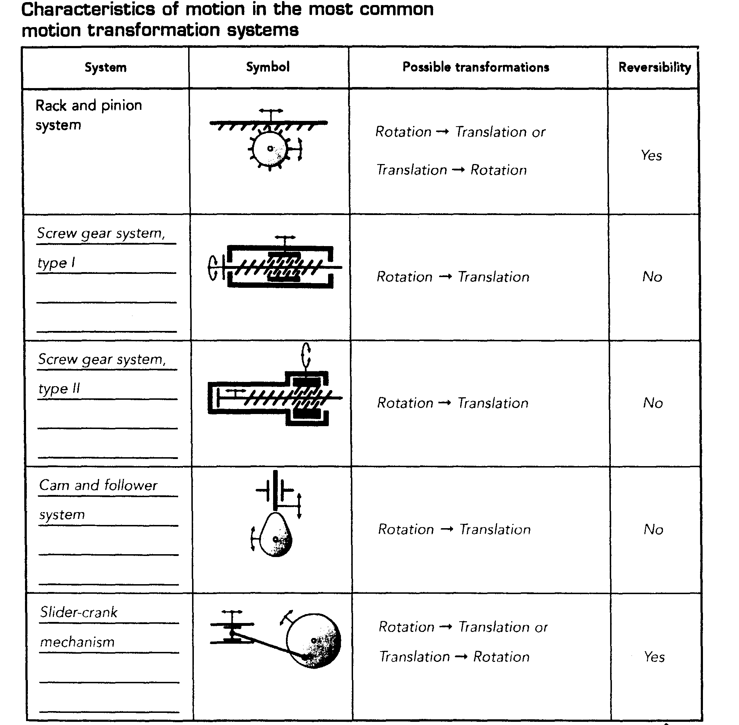

- Speed changes
- A speed change occurs in a motion transmission system when the driver does not turn at the same speed as the driven component.
- A speed ratio is equivalent to the ratio between the gear diameters or between the numbers of teeth on each gear.

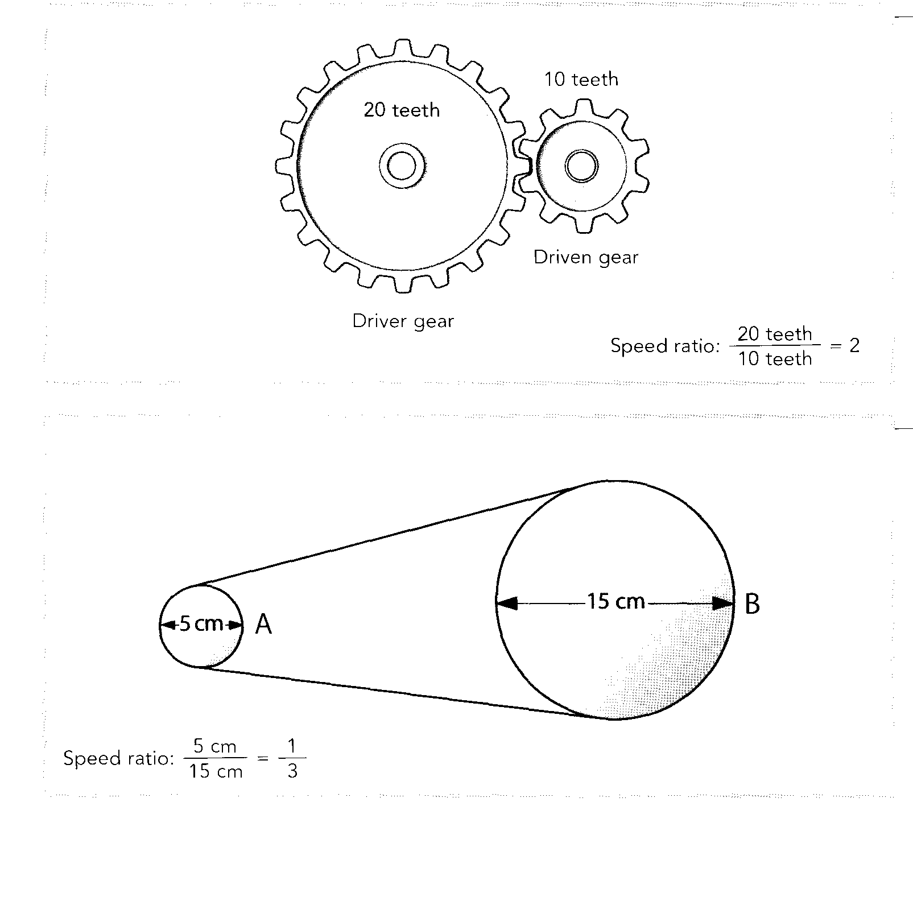
Constraints
- Types of constraints (effect of external force on a material)
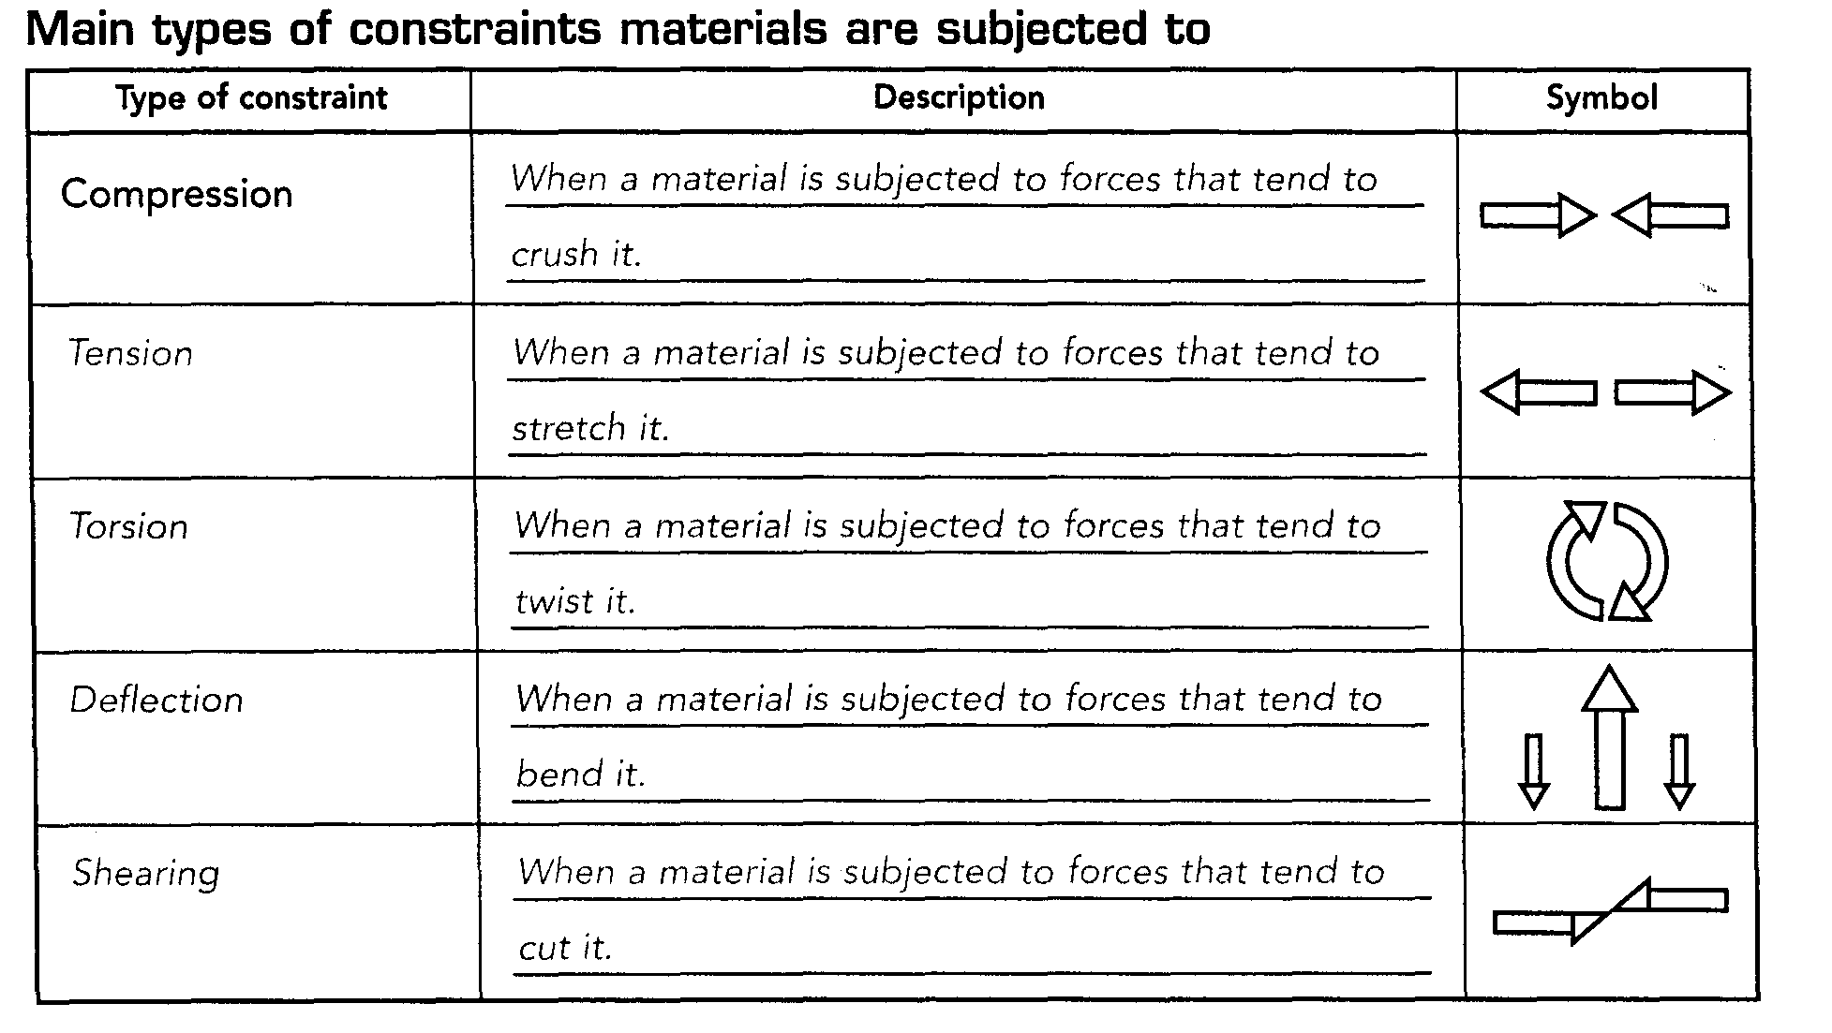

- Mechanical properties
- Hardness : ability to resist indentation or abrasion
- Elasticity: ability to return to their original shapes after undergoing a constraint
- Malleability: ability to be flattened without breaking
- Resilience: ability to resist shock without breaking
- Resistance to corrosion: ability to resist rusting
- Ductility: ability to be stretched without breaking
- Stiffness: ability to retain their shape when subjected to various constraints
- Thermal conductivity: ability to transmit heat
- Electrical conductivity: ability to carry an electric current
Materials and their properties
- The properties of different materials determine whether they will be an appropriate choice for
different applications and uses.
Material | Properties
Metals and Alloys | - shiny  - conduct heat and electricity  - malleable (can be bent)  - ductile (can be made into wires)  - some metals resist corrosion (rustinghard  - strong  - durable  - need to be protected by paint, grease or metal plating.
Wood and Modified Wood | - hard  - good elasticity  - moist wood is very resilient  - somewhat malleable when heated strong  - good insulator of heat and electricity  - lightweight  - fungi, microorganisms and insects cause wood to rot  - produces CO₂ when burned  - can be varnished, painted or treated with protective coatings to prevent rot.
Plastics | - light weight  - strong  - good resistance to corrosion  - good chemical resistance  - waterproof  - easily moulded  - good electrical insulator  - changes color when exposed to sunlight  - resistant to corrosion  - made with fossil fuels  - cannot be decomposed by decomposers.
Ceramics | - very hard  - heat and wear resistant  - very durable  - can be degraded by some acids and bases  - thermal shock causes deterioration of properties
Composite | - enhanced properties

Forces, Work and Energy
Distinguish between heat and temperature
Heat is the transfer of thermal energy from the warmer to the cooler environment.
Temperature measures the degree of agitation of the particles of a substance. The more the particles are warmed up, the greater their agitation and the higher the temperature!

Atmosphere
- Explain how tides are formed
Tides are formed by the gravitational force of the moon and to a lesser extent the Sun on the oceans of the Earth. There are two high tides a day: one on the side of the Earth closest to the Moon and one on the opposite side. The two low tides occur in the parts of the worlds where the water does not swell.
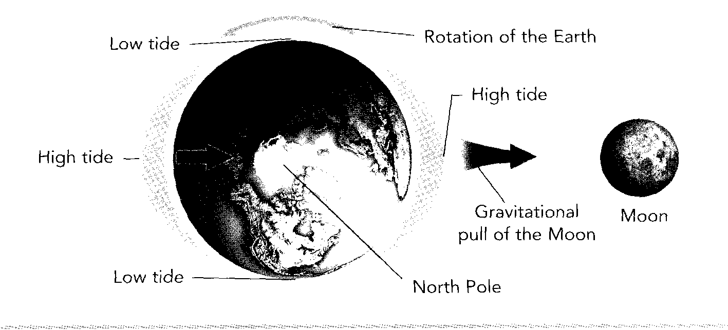
- Factors that affect the quantity of solar energy that reaches the Earth’s surface (reflection and absorption of solar energy by the atmosphere or surfaces , the curvature)
- White ice and snow reflect sunlight while dark water absorbs it. (Albedo effect)

- The equatorial regions of the world receive more solar energy than the polar region because of the curvature of the Earth. This difference in temperature gives rises to winds and ocean currents that carry heat from the equator to the poles.

- Describe the greenhouse effect
- The Greenhouse effect is a natural phenomenon that allows the Earth to retain some of the heat it receives from the Sun. It is made up of a layer of gases that trap infrared rays and send them back to Earth. These gases are carbon dioxide, methane, nitrous oxide and water vapor.
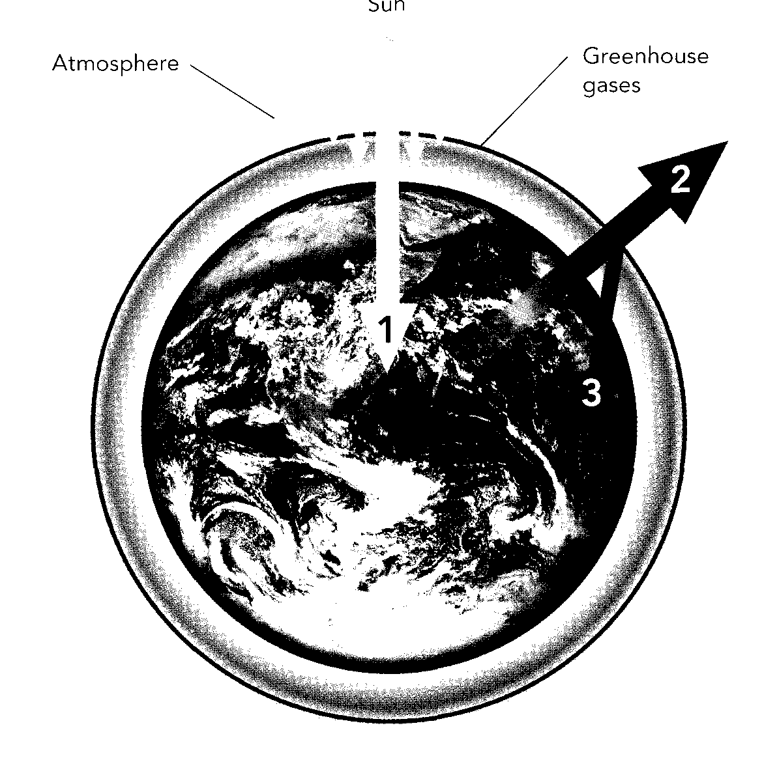

- Consequences of higher concentration of greenhouse gases
- Global warming,
- Melting pack ice and glaciers
- Disturbances in ecosystems

- Define air mass
- An air mass is a large expanse of the atmosphere with relatively uniform temperature and humidity. An air mass from a tropical region is a warm air mass. An air mass from the polar region is a cold air mass.
- Describe a cold front and a warm front
- A front occurs when two air masses meet. When two air masses meet, the denser cold air slides beneath the lighter warm air. The line where the two masses meet is called a front. It is a transition zone where wind direction, temperature and relative humidity change rapidly.

- A cold front occurs when a cold air mass meets a warm air mass. The warm air mass rises quickly and cools. This causes puffy clouds, wind and heavy rain.
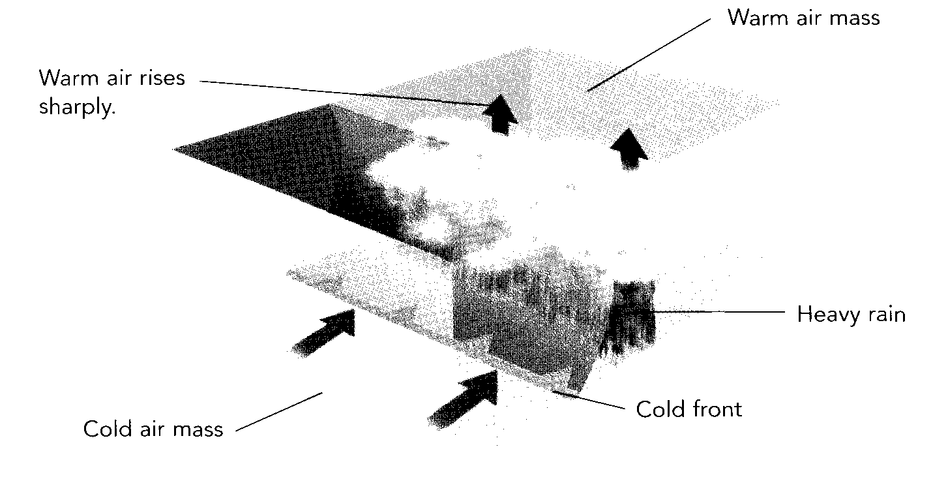
- A warm front occurs when a warm air mass meets a cold air mass. Thwarm air mass rises gently over the cold air mass. This causes light, layered clouds, cloudy weather and showers that are slow to disperse.

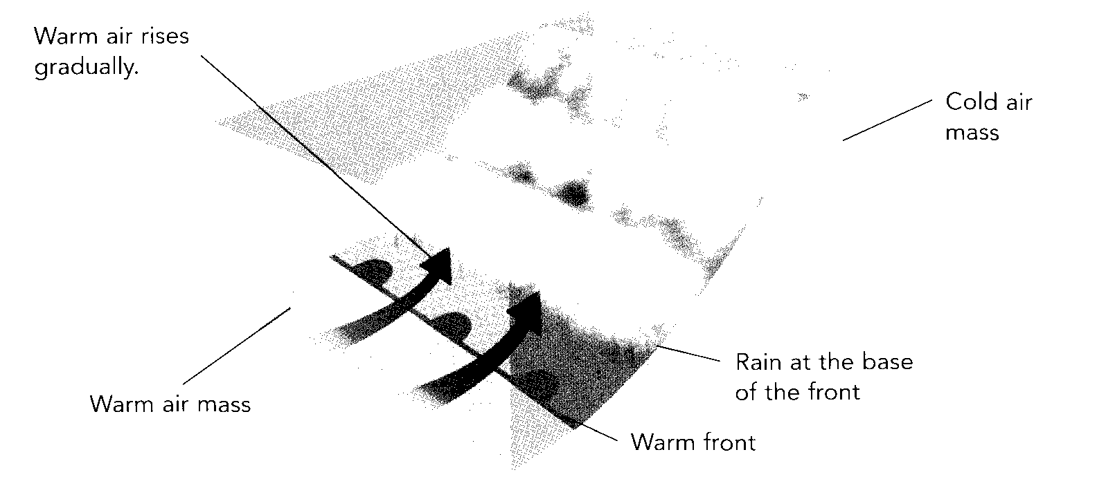

- Explain how winds are formed (pressure variations, uneven of the heating of the Earth’s surface)
- Warm humid air above the equator rises in the atmosphere (low- pressure zones) and heads toward the poles and descends over cold dry regions (high-pressure zones). At the same time, the cold polar air makes its way to the equator. Air always travels from low-pressure zones to high-pressure zones!

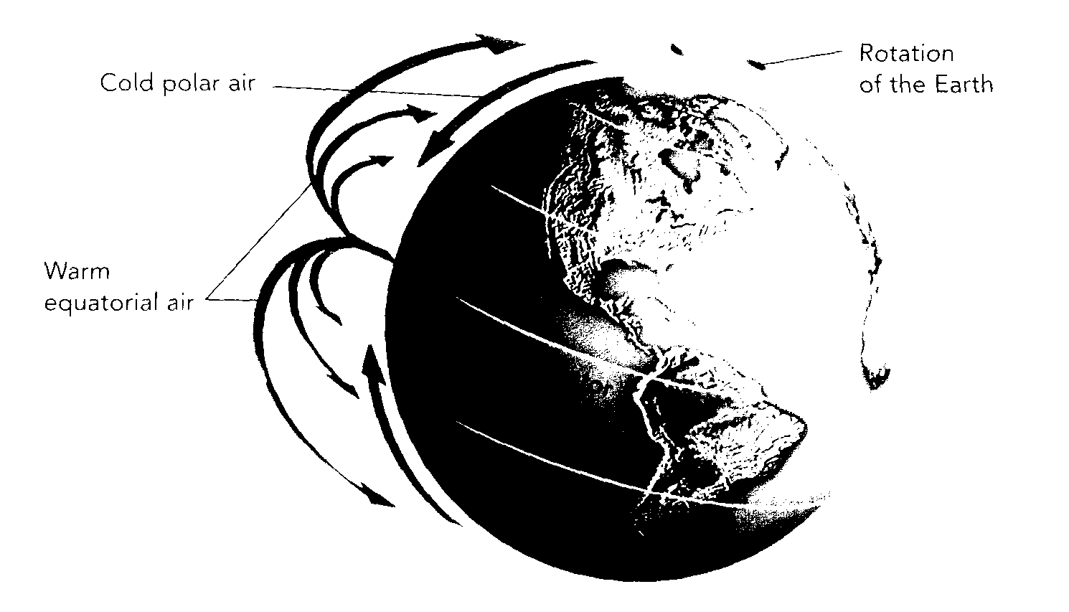

- Explain how cyclones and anticyclones are formed.
- Cyclones (depressions) occur when warm air rises and leaves an empty space beneath it. The space becomes a low pressure area called a depression.
- Anticyclones occur when air cools and sinks toward the ground, compressing the particles beneath and creating an area of high pressure.
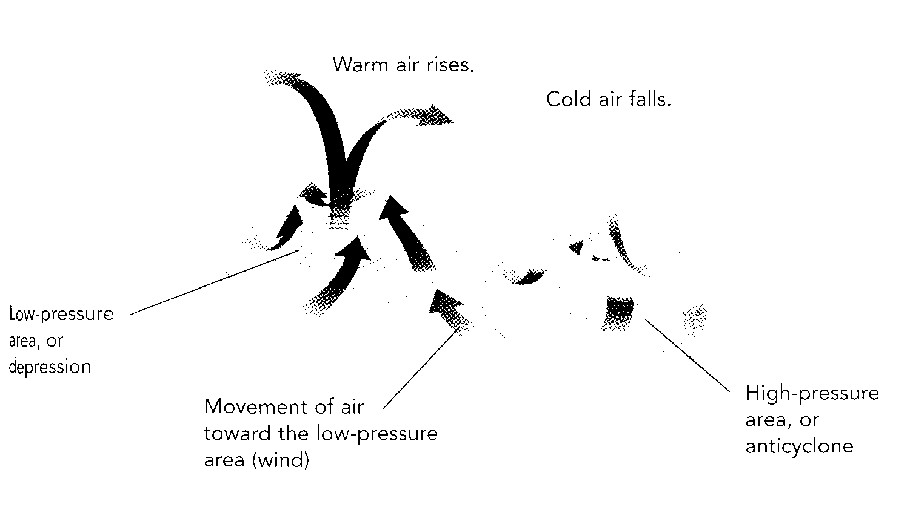

Physical properties of solutions
- Concentration in g/L and % and ppm.
Formulas: $c=\frac{m}{V}$ C= concentration
m = mass of solute
V= volume of solution

g/L Concentration. in g/L = grams of solute
volume of solution in litres

% Concentration in % = grams of solute x 100
volume of solution in milliliters

ppm Concentration in ppm = milligrams of solute
volume of solution in litres

Examples:
- A pitcher containing 2000 ml of iced tea contains 30 g of sugar. What is the sugar concentration of this solution in grams per liter?
Mass of solute = 30g
V olume of solution= 2000 ml = 0.2 L

Concentration= 30g
0.2L

= 150 g/L

- A variety of orange juice contains 25 g of carbohydrates per 250-mL serving. What is the concentration of carbohydrates in % m/V?
Mass of solute = 25 g
Volume of solution – 250 ml

Concentration= 25g- x 100
250 ml

= 10 %
- Synthetic fertilizers are used in the garden. We dissolve 0.1 g of fertilizer in 100 ml of water to make a solution. Calculate , in ppm, the concentration of this solution.
Mass of solute = 0.1 g = 100mg
Volume of solution – 250 ml = 0.25L

Concentration= 100mg-
0.25L

= 400ppm
- Define concept of electrolyte
- A substance that, when dissolved in water, allows an electric current to flow through the solution. Examples: salt solutions, acids and bases.

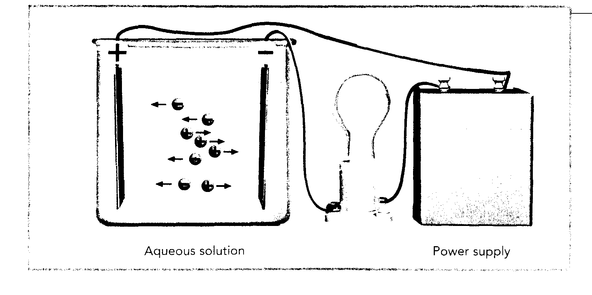

- Describes the pH scale (acidity, alkalinity, neutrality, increasing and decreasing pH)

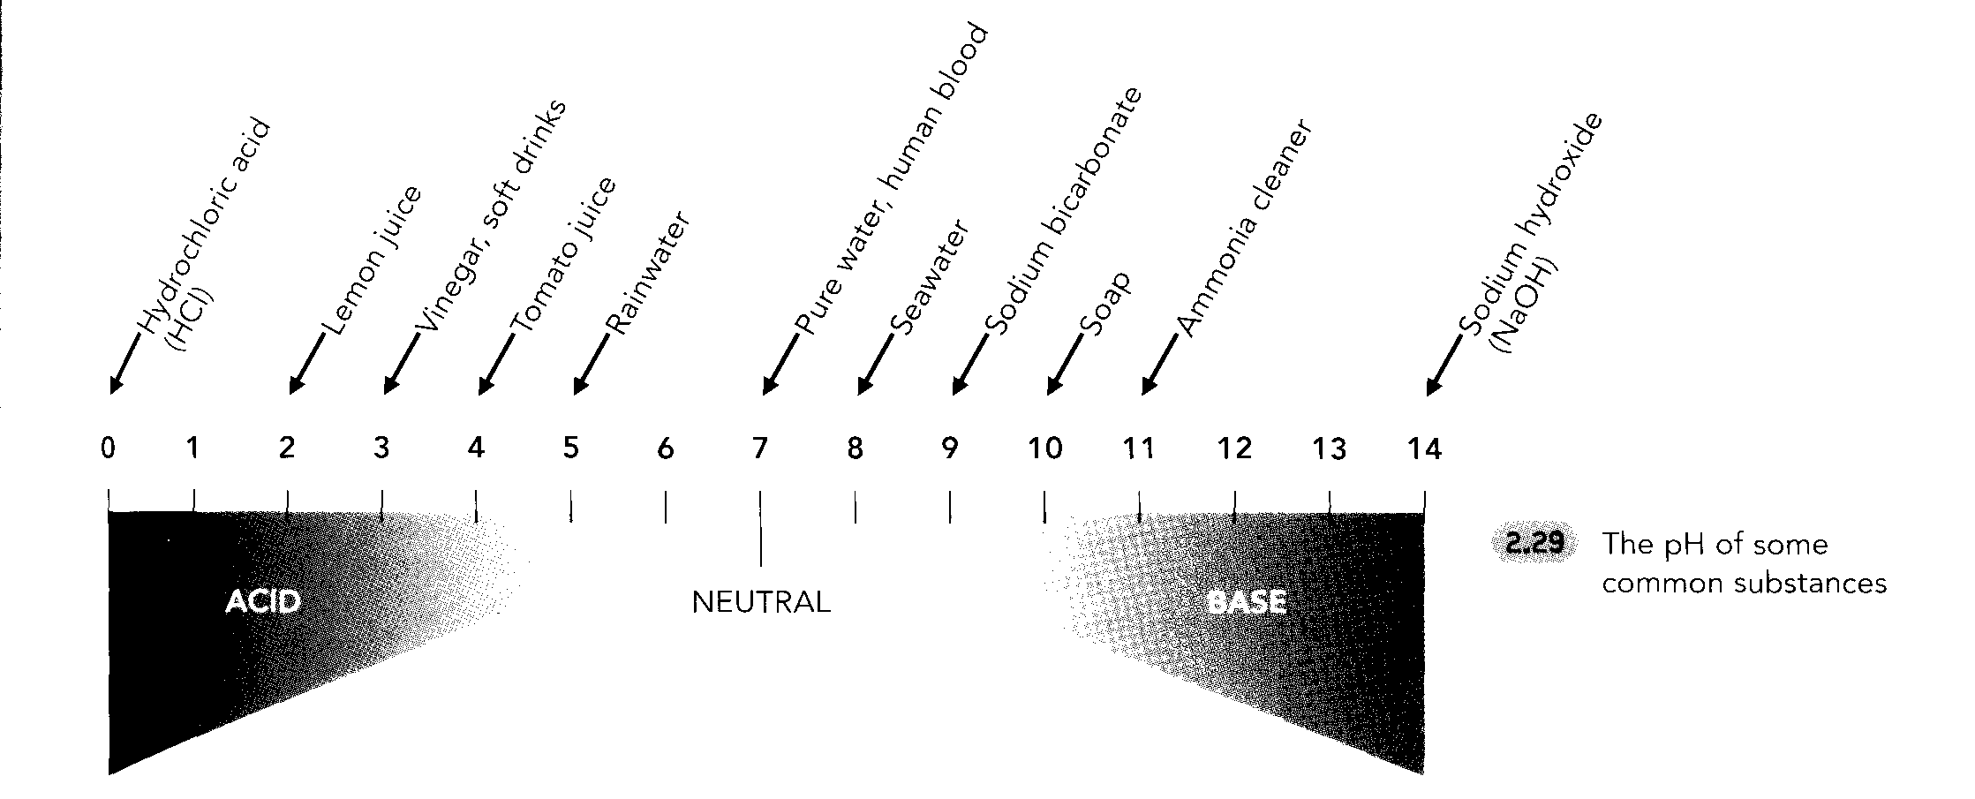
- Determines the pH of different solutions
- Acids have a pH < 7
- Bases have a pH > 7
- Distilled water and other neutral substances have a pH = 7
- When acids dissolve in water, they release H⁺ ions.
- When bases dissolve in water, they release OH⁻ ions.

- Describe what allows aqueous solutions to conduct(electrical conductivity)
- Ions must be present
- Ions must be mobile
- Ions must flow in a specific direction

Hydrosphere
- Describe what a catchment area.
- It is an area of land which all the inland waters drain in the same larger body of water.

- Impacts of human activity on the waterways in a catchment area
- Fertilizers, pesticides and other contaminants in the soil such as heavy metals from landfills, mining wastes and hydrocarbons from gas stations end up in our rivers etc. and accumulate in a larger body of water in the same watershed or catchment area.
- Define salinity
- This is a measure of the amount of salt dissolved in a liquid.
- The salinity of different oceans vary.
- Near the poles, melting pack ice and glaciers dilute the water and reduce its salt content (salinity) to nearly 3 %.
- In the Red Sea, heat and drought (lack of rain) accelerate water evaporation and concentrate the salts, raising the salinity to 4%.
- Density of water variations due to salinity and temperature
- The higher the salinity, the denser the water is.
- In regions where water evaporates quickly, the salt water increases, and the salty water tends to sink beneath the les salty water.
- The colder the water, the denser it is so cold water tends to sink.
- Near the poles, the surface water cools on contact with the air, sinks and then moves along the ocean floor.
- Factors that affect ocean currents (surface and deep)
- Wind
- Earth’s rotation
- Temperature
- Salinity
- Role of thermohaline circulation in global climate regulation
- Thermohaline circulation is responsible fro major transfers of heat around the world. Without it the differences in temperature between the equator and the poles would be much more dramatic. The ocean is essential in regulating the Earth’s climate. Example, the effect of the Gulf stream on the climate of the East coast of North America.
- Distinguishes between an ice floe and pack ice
- Glaciers are formed from freshwater on land
- Pack ice is formed from seawater in the Earth’s polar regions.

- Impacts of the melting of glaciers and ice floes
- Pack ice does not affect sea-level since it floats upon ocean water but glaciers do because they add to the total amount of water in the ocean when they melt.
- Pack ice affects thermohaline circulation because when salt water freezes, water rejects its salt content (leaving pure ice). The remaining surface water, made dense by the extra salinity, sinks, leading to the production of dense water masses. This maintains the thermohaline circulation.
- When pack ice melts the influx of freshwater is making the water less dense and this influences thermohaline circulation. (slows down ocean currents)

Lithosphere
Distinguishes between a mineral and an ore
- Minerals are not man-made. They are solid inorganic substances (not derived from animals or plants) with clearly defined composition and properties. Each mineral has its own chemical composition. Examples: gold, copper, iron, quartz, copper sulphate.
- An ore is a rock containing the mineral that is extracted from the lithosphere.

- Impacts of mining or the transformation of minerals on the environment.
- Effect on land
- Deforestation: Mining requires large areas of land to be cleared so that the earth could be dug into by the miners. For this reason, large-scale deforestation is required to be carried out in the areas where mining has to be done.
- Loss of Biodiversity: The forests that are cleared for mining purposes are home to a large number of organisms.
- Pollution: Despite measures being taken to release the chemical waste into the nearby rivers through pipes, a large amount of chemicals still leak out onto the land. This changes the chemical composition of the land. Besides this, since the chemicals are poisonous, they make the soil unsuitable for plants to grow. Also, the organisms that live in the soil find the polluted environment hostile for their survival.

- Effect on water
- Pollution: Chemicals like mercury, cyanide, sulfuric acid, arsenic and methyl mercury are used in various stages of mining. Most of the chemicals are released into nearby water bodies that leads to water pollution.
- Loss of Aquatic Life: Release of toxic chemicals into the water is obviously harmful for the flora and fauna of the water bodies

- Soil horizons (layers and thickness of layers).
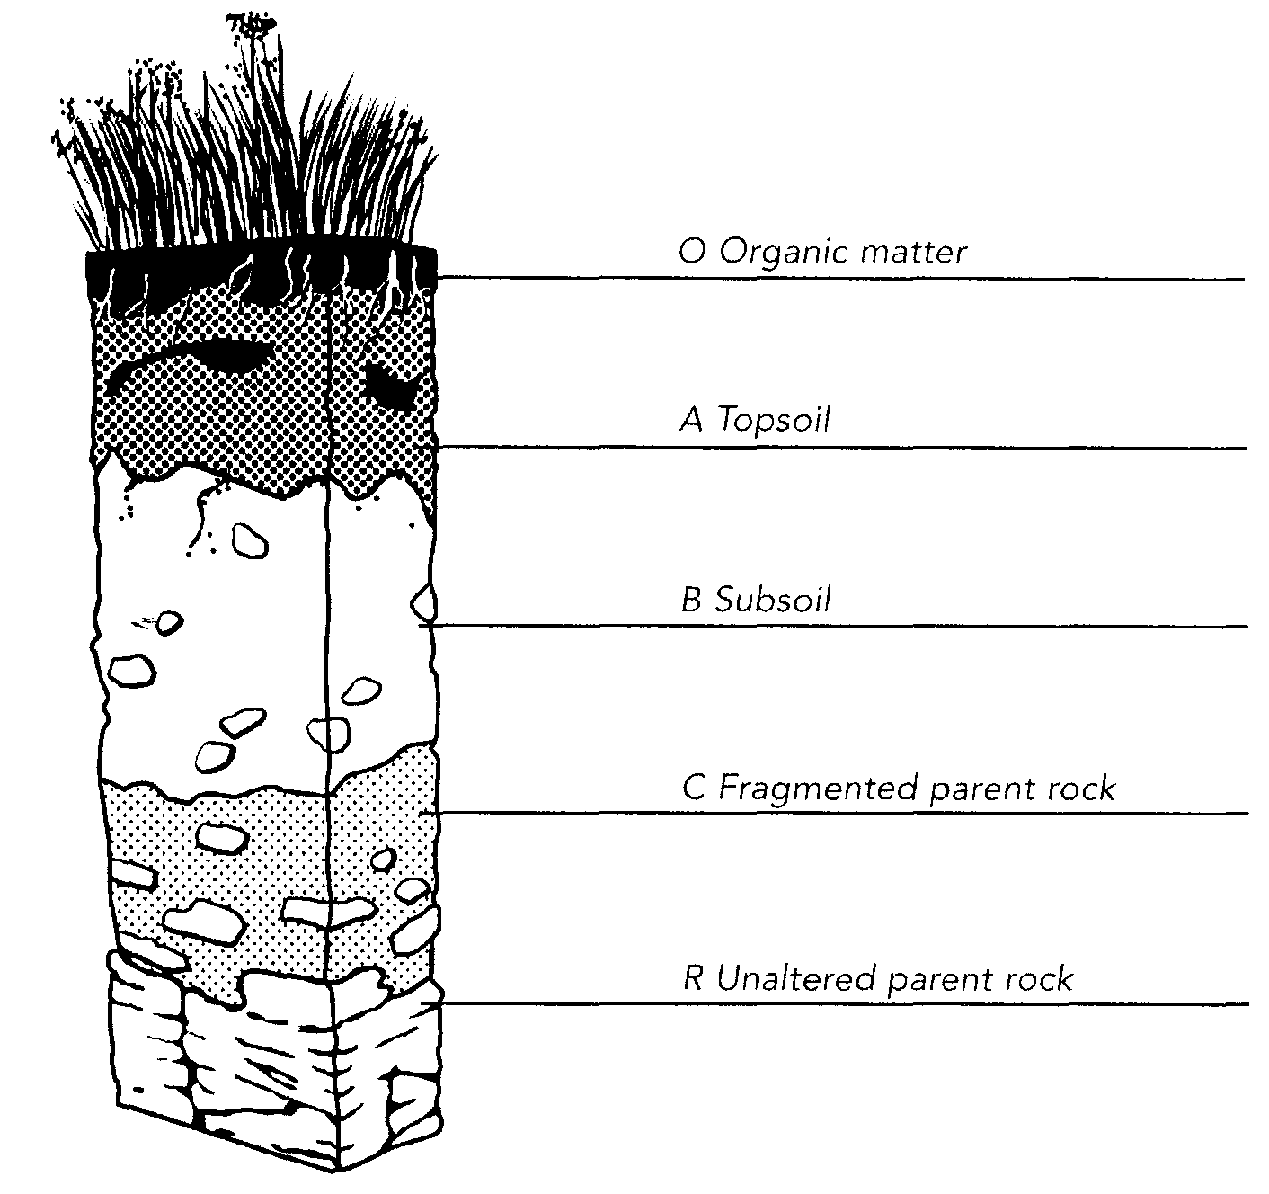
- Chemical and biological reactivity of soil based on its composition (oxidation, acid-base neutralization, decomposition)
- Wastes containing carbon in the soil is decomposed by organisms called decomposers which emit carbon dioxide and methane in the process.
- Soil has the ability to neutralize a certain amount of acidic or alkaline substances without affecting its pH. This is called buffering capacity.

- Define permafrost and consequences of a rise in temperature of permafrost
- Permafrost is ground whose temperature has been 0°C or lower for at least two years.
- Permafrost comprises 24% of the land in the Northern Hemisphere, and stores massive amounts of carbon. As a result of climate change, permafrost is at risk of melting, releasing the stored carbon in the form of carbon dioxide and methane, which are powerful heat-trapping gases. In addition, permafrost is structurally important, and its melting has been known to cause erosion, disappearance of lakes, landslides, and ground stability. It will also cause changes in plant species composition at high latitudes.

Biogeochemical cycles
- Carbon cycle
- Photosynthesis
- Ingestion
- Respiration
- Decomposition of wastes
- Dissolution in water (formation of shells and skeletons)
- Formation of carbonate rock
- Combustion of fossil fuels
- Forest fires
- Volcanic eruptions

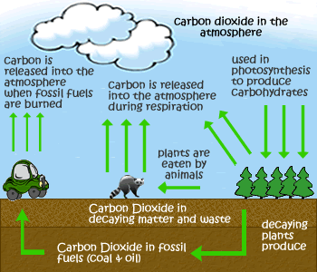

- Nitrogen cycle
- Nitrogen fixation
- Nitrification
- Nitrogen absorption
- Decomposition of wastes
- Denitrification

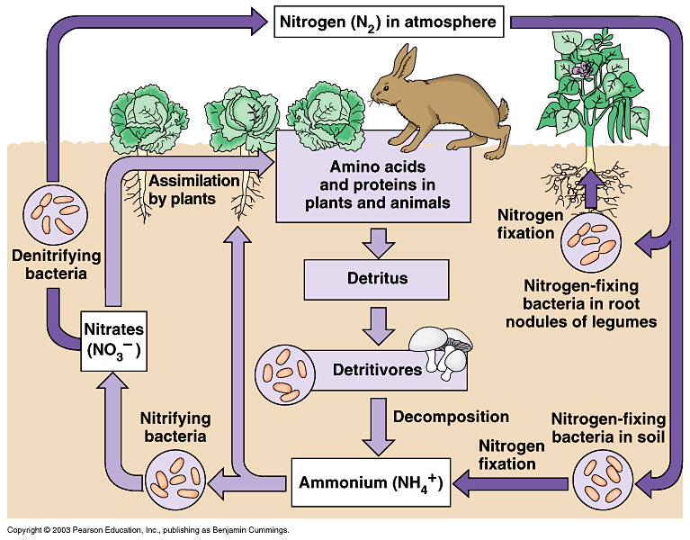

Climate zones
- Factors that affect the distribution of biomes
- latitude, humidity, temperature, and salinity

- Describes different terrestrial biomes (fauna, flora, climate, type of soil)
- Tropical forests
- Boreal forests
- Temperate forests
- Grasslands and shrub lands
- Arctic tundra
- Deserts
- Alpine biomes

- Describes different marine biomes (fauna, flora, temperature, salinity)
- Freshwater biomes (lakes, rivers, wetlands)
- Marine biomes (estuaries, oceans and seas, coral reefs)

Ecology
- Populations
- Density (the number of individuals per unit of area or volume)

Formula:
Population Density= Number of individuals
Volume or area

Example: In a 30 000-km² African wildlife park, there are 15 000 giraffes. What is the population density of giraffes per km²?

Population Density= 15 000 giraffes
30 000 km³

= 0.5 giraffes/km³

- Distribution (the way in which populations are dispersed within their habitat.

- Clumped distribution ex. Many fish move around in schools. This reduces the effort involved in swimming, provides some protection from predators and helps the fish feed more efficiently.

- Uniform distribution Ex. Northern gannets space their nests at regular intervals to allow each bird a certain minimal territory.

- Random distribution Ex. Bushes are dispersed at random because the individuals in the population cannot clump or spread out.

- Biological cycle
This refers to a cycle of alternating periods of rise and fall in the size of a population. These periods are of fixed duration and are repeated continually.

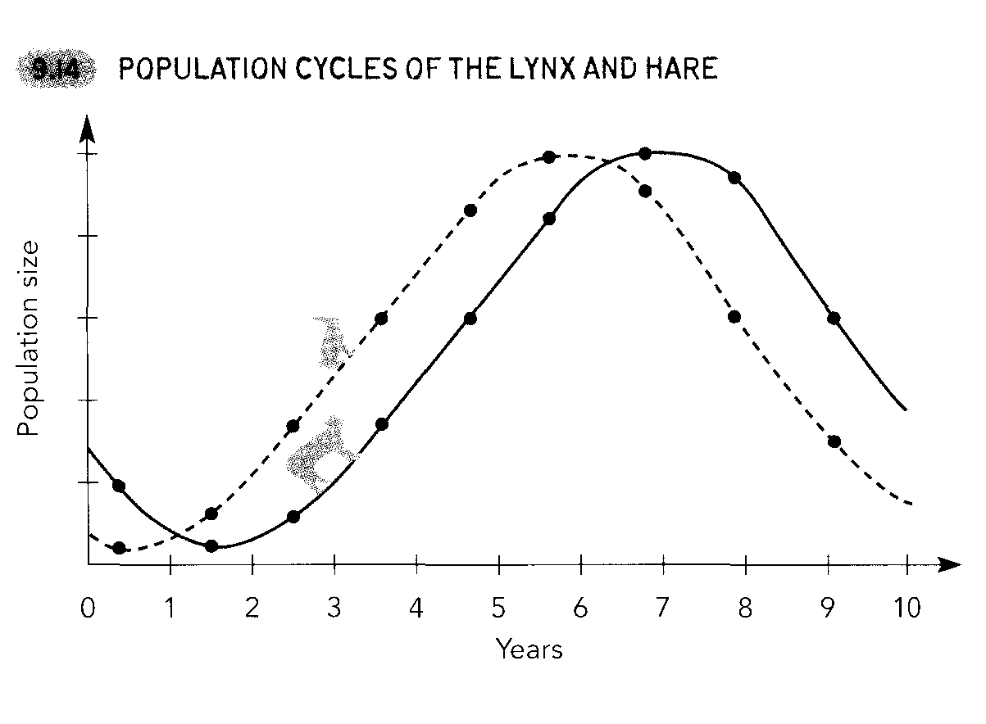
- Influence of biotic and abiotic factors on a population.
- Natality (births)
- Mortality (deaths)
- Immigration (arrivals)
- Emigration (departures)

- The effect of availability of resources on reproduction and survival.
- Individuals of a population reproduce more easily when there is more food.

- Definition of a community
- This is a group of populations of different species that interact. Ex. The squirrels, fungi, trees, and mosquitoes in a forest.

- Definition of biodiversity.
- This is a term used to describe the variety of species living in a community. The biodiversity of a population is high when there are many different species in it and the relative abundance of different species is similar.

- Factors that affect the biodiversity in a community
- Abiotic (amount of light, soil or water pH, terrain, depth of snow, temperature, air humidity)
- Biotic (birth rate, disease, amount of food, predation, competition, human activity)

- Disturbances in a community
- Natural (volcanic eruptions, forest fires, droughts, frost, heat waves etc.)
- Human (logging, oil spills, littering etc.)

- Definition of ecosystem (relationship between individuals in a community and abiotic factors in the environment) Examples of ecosystems: a forest, a lake, an aquarium, a mountain

- Trophic relationships (producers, consumers, decomposers)

Producers: Organisms that transform inorganic matter in the environment into organic matter.. They use matter, such as water and soil elements, and energy such as sunlight, to produce the material of life. Examples of producers: plants, algae and certain bacteria

Consumers: Organisms that obtain the energy they need by eating other living organisms or their products ( eggs, fruits,etc.) Examples of consumers: owls, birds, cows, zooplankton etc.
- First-order (primary) consumers: consumers that feed on producers.
- Second-order consumers: eat first-order consumers
- Third-order consumers: eat second-order consumers etc.

Decomposers: organisms that feed on detritus (dead organic matter) such as fallen leaves, wood from dead trees, animal remains and excrement. Decomposers are connected to all other trophic levels. Examples of decomposers: certain worms, all fungi, some bacteria, and certain insects.
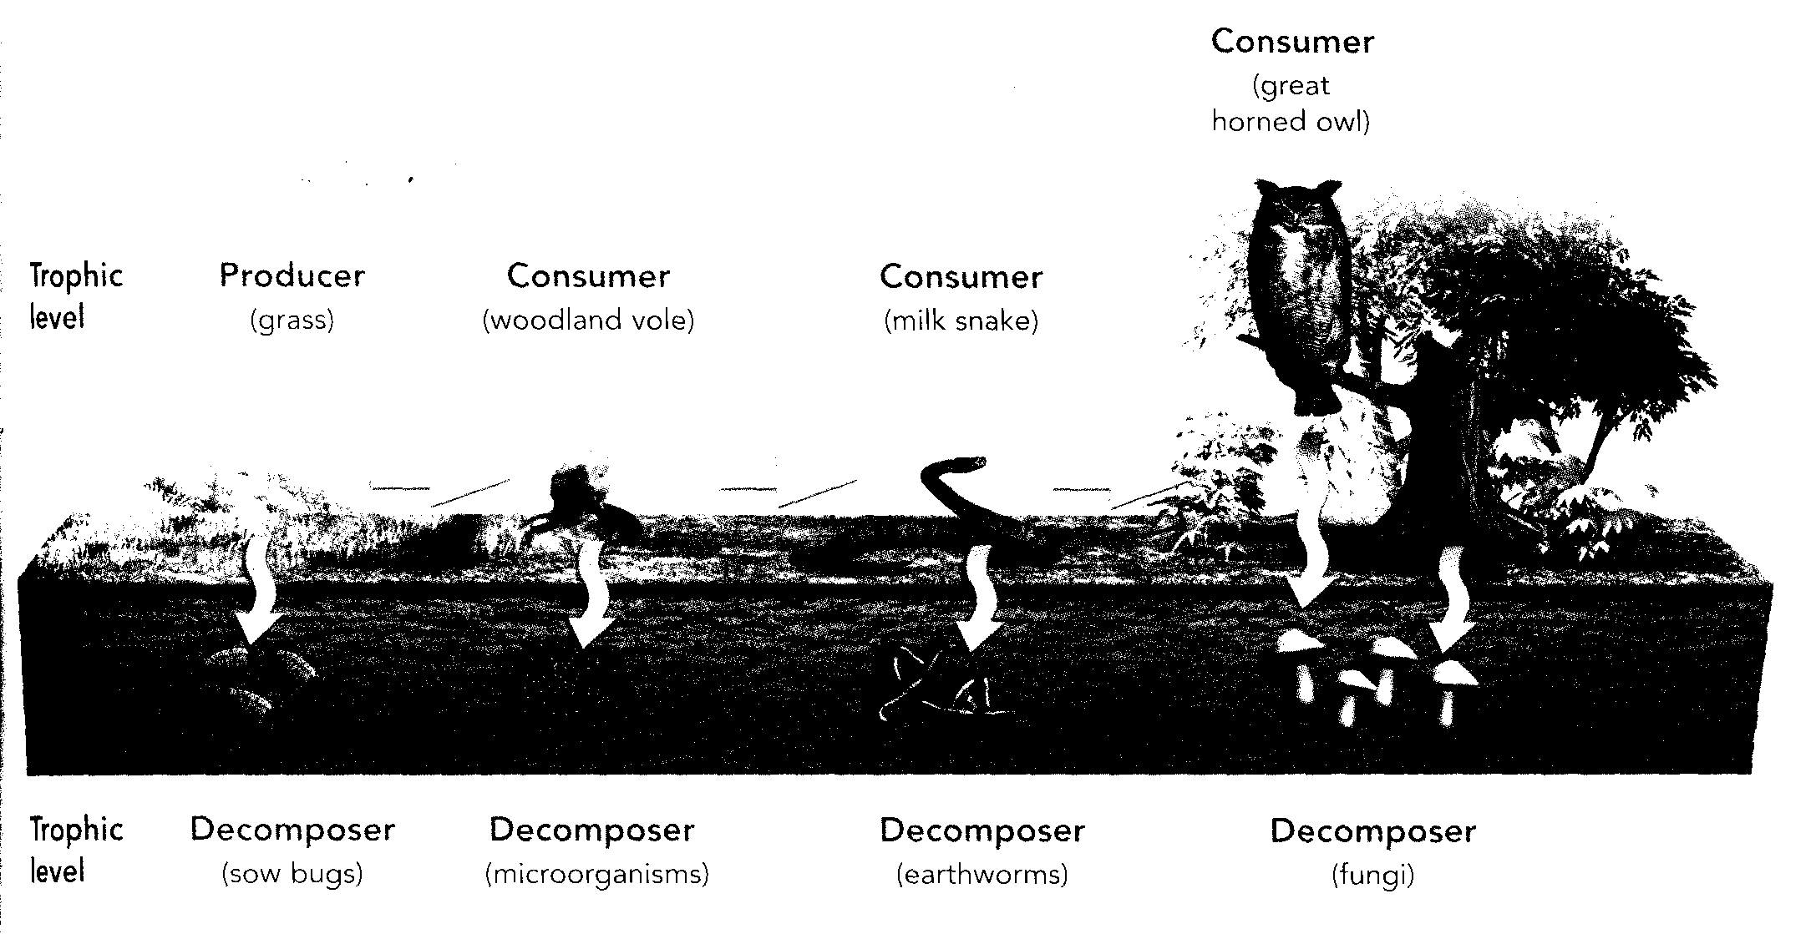

- Explain the relationships of a food web.
Example: the following diagram shows the food web of a corn field.
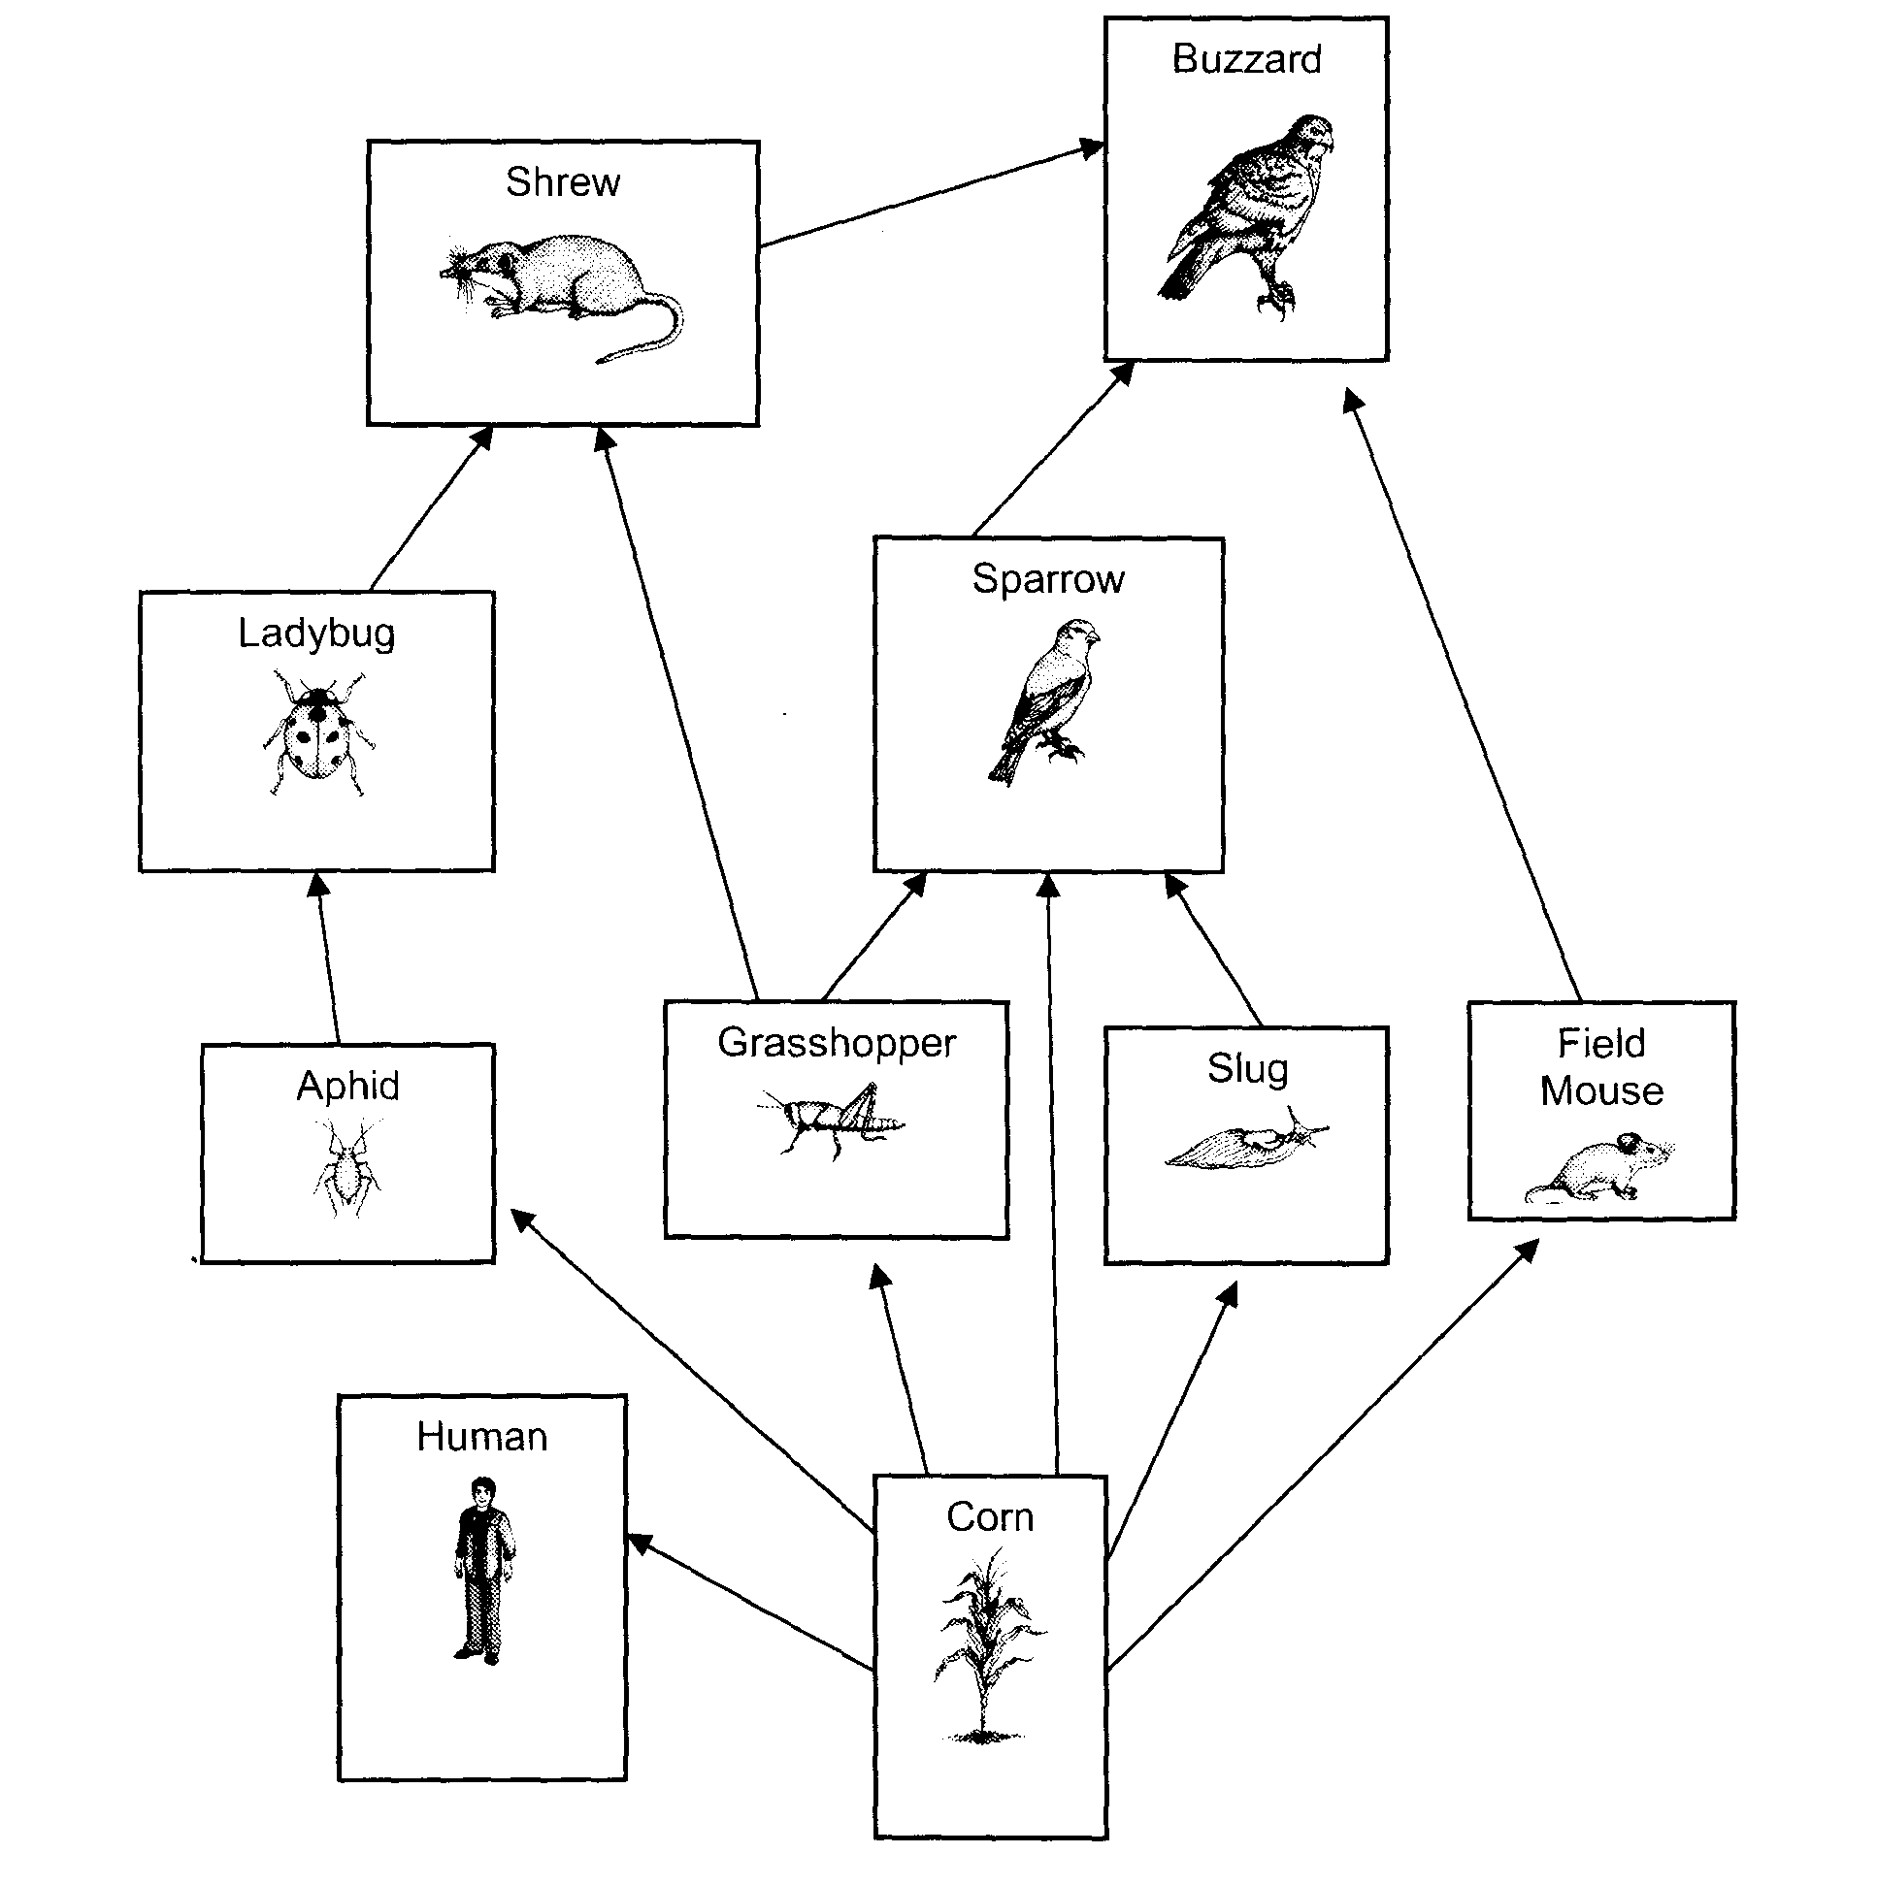
Which would have a greater impact on the food chain of the corn filed: the extinction of ladybugs or the extinction of slugs?

The extinction of ladybugs would have a greater impact on the impact on the food web because ladybugs eat aphids and if ladybugs become extinct, aphids will have no predators . Since aphids eat corn, the corn will disappear more quickly and this affects all the organisms in the food web.
Slugs are eaten by sparrows but these have other food sources. The extinction of slugs does not really endanger the life of other organisms in the food web.

- Define Primary productivity
- Quantity of organic matter produced by producers such as plants and phytoplankton in a given territory

- Explain the effect of certain factors on primary productivity.
- The amount of light (light is needed for photosynthesis))
- Amount of water (water is necessary for photosynthesis)
- Access to essential nutrients such as carbon, nitrogen, phosphorous and potassium.
- Temperature (some weather conditions promote the growth of producers)
- Disease

- Describe material and energy flow in an ecosystem.
- Both materials and energy flow in an ecosystem but materials are recycled and energy is not.

- The primary source of energy in an ecosystem is sunlight. Plants transform the energy from the Sun into chemical energy through photosynthesis and consumers obtain this energy by eating plants or other consumers. The energy is stored in their tissues.

- A large part of this energy is lost at each trophic level because organisms release it as heat or in the form of waste. They also use a lot to move, grow, and reproduce.

- Ecosystems must receive a continual supply of energy from the sun because energy is not recycles like matter is.

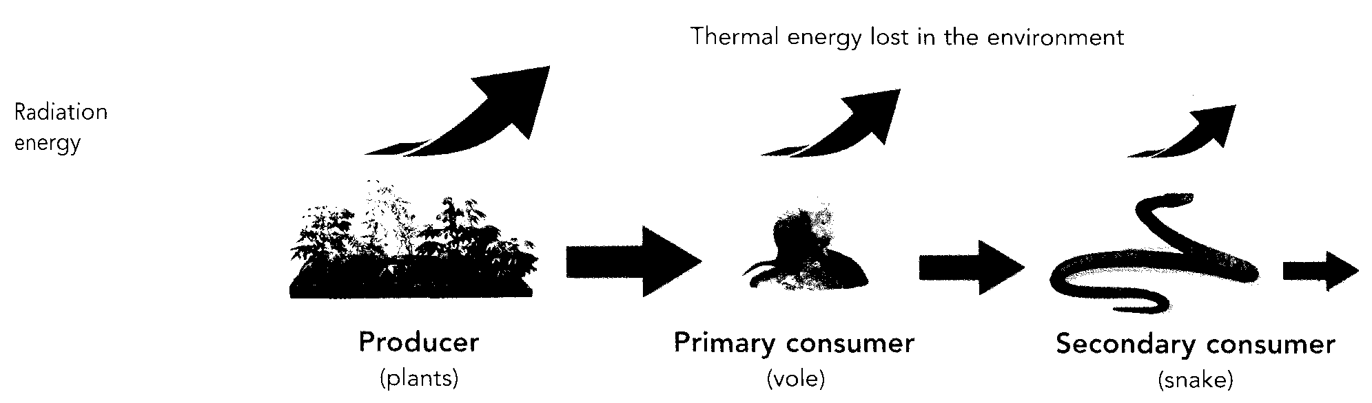

- Chemical recycling ( action of plants and decomposers, erosion)
- Matter stays in circulation in the ecosystem. Producers make inorganic matter into organic matter which is consumed by consumers. Decomposers in a food chain break down the organic matter into inorganic matter which producers use to make organic matter once again.

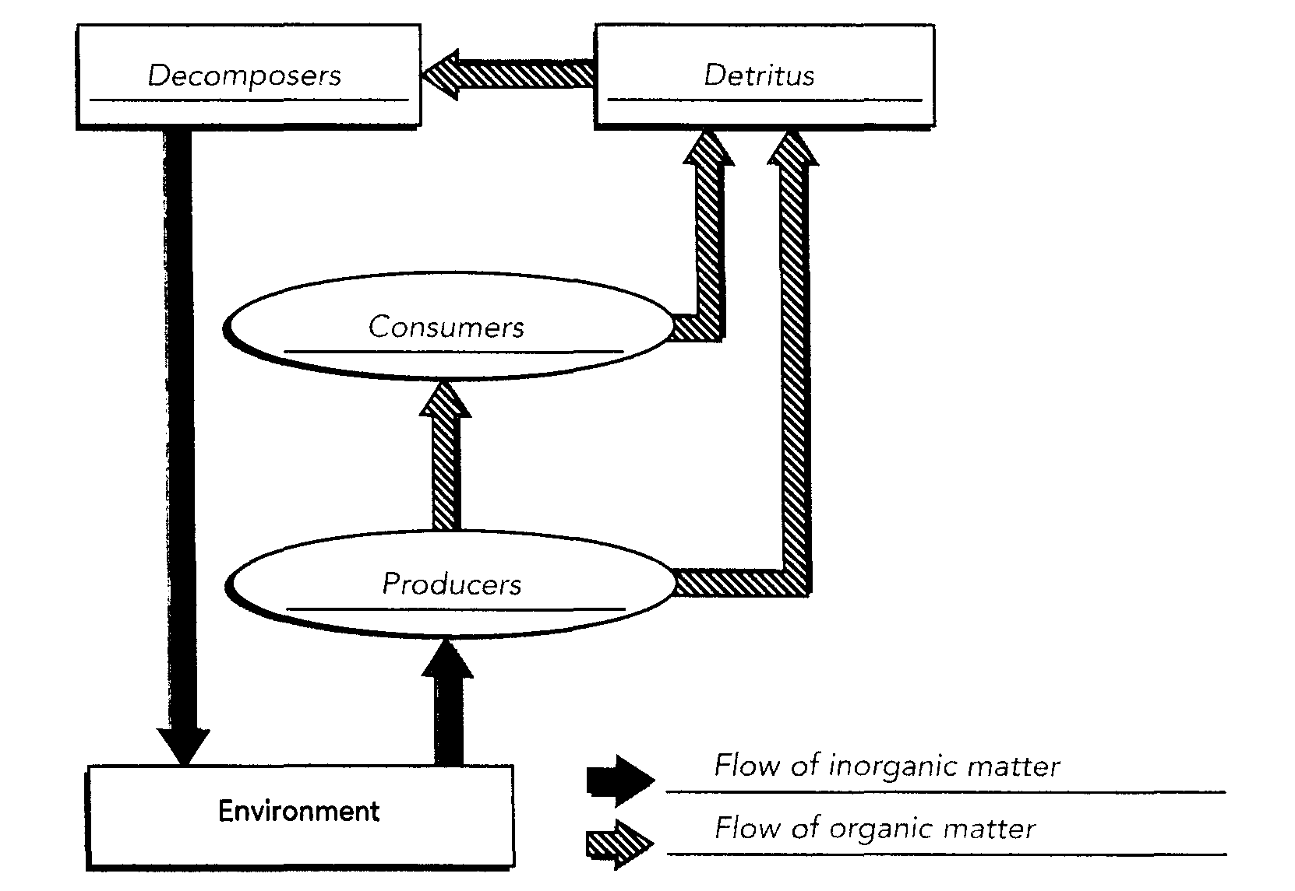

Example: When a hare grazes on clover, the substances in the clover are transferred to the hare. If a lynx eats the hare, he gains access to the matter now in the hare, and so on. In the end, the matter in the detritus left by the clover, hare, lynx etc. becomes available to decomposers which break it down into inorganic matter and return it to the ecosystem where it can be used once again by the clover.

