Name: ________________________________
Science and Technology 404
Review Package
2011-2012
The Material World
Organization
Groups and periods

- The following shows the Rutherford-Bohr model of an atom.

- What is the name of the group this element belongs to?

- To what period does this element belong?

- Write the symbol for the alkaline Earth metal in period 3, and represent this element using the Rutherford-Bohr model.

- Listed below are the characteristics of an element on the periodic table.
- It is a nonmetal
- Its outermost energy level has seven electrons.
- It is used to purify and disinfect water.

What is the name of the group this element belongs to?

- Which of the following are ions? Explain your answer.
- Na
- Cl¹⁻
- Mg²⁺
- K

Lewis notation
- Refer to your periodic table.
- Determine the number of valence electrons each of the elements has.
- Draw the Lewis diagram.
- Name the chemical group (family) to which the element belongs (example: alkali metals, alkaline-earth metals, halogens or inert gases)

Element | Number of valence electrons | Lewis Diagram | Name of chemical group
Cl

K

Ar

N |  |  | Nitrogen group
Al |  |  | Boron group
O |  |  | Oxygen group
C |  |  | Carbon group
Ca

Chemical changes
Combustion
- What are three necessary conditions for combustion to take place?

- Which part of the fire triangle is involved in each of the following situations? Explain your answers.

- The carbon dioxide (CO₂) gas that comes out of an extinguisher is a powerful spray that puts out small paper fires by scattering the pieces of material involved.

- CO₂ from an extinguisher has a cooling effect as it comes out of the extinguisher at a temperature of- 78°C.

- During a forest fire, firefighters begin clear-cutting a threatened area. They cut a 50-m-wide stretch of forest a few kilometres ahead of the fire.

- A fire blanket can smother a fire.

Law of Conservation of mass

- Balance the following equations and then draw diagrams of the molecules in the chemical reactions.

- N₂ + H₂ NH₃

- Mg + O₂ MgO

- Na + H₂O NaOH + H₂

- Fe + O₂ Fe₂O₃

- In a small lake affected by acid rain on Grand Island, 73 Kg of hydrochloric acid (HCl) reacted with calcium carbonate (CaCO₃) to produce 111 kg of calcium chloride (CaCl₂), 18 kg of water (H₂O) and 44 kg of carbon dioxide (CO₂).The balanced equation for a particular chemical reaction is:
2HCl + CaCO₃ -----> CaCl₂ + H₂O + CO₂

What mass of calcium carbonate was needed to neutralize the small lake?

- In the lab, you react 8.5 g of NaNO₃ with 9.8 g of H₂SO₄ . You obtain 12.0 g of
NaHSO₄ and a certain quantity of HNO₃. What is this quantity of HNO₃?

- The reaction caused by the burning of butane in air is represented by the following equation:
2 C₄H_{10 (g)} + 13 O_{2(g)} ----> 8 CO_{2(g)} + 10 H₂O_{(g)} + Energy

During a laboratory experiment, you reacted 29 g of butane (C₄H₁₀) in the presence of oxygen (O₂). You observed that 88 g of carbon dioxide (CO₂) and 45 g of water vapour (H₂O) form. What mass of oxygen gas (O₂) did you use in this experiment?

Electricity and electromagnetism
Electric charge

- Will the following atoms be positively or negatively charged? Explain your answers.

- an atom containing 12 protons and 10 electrons

- an atom containing 8 protons and 10 electrons

Static electricity

- Five spheres ( A to E) carry an electric charge. If A carries a positive charge, what is the charge of of the other spheres?

E
C
D
B
C
A
B
A

Sphere | Charge on the sphere
B
C
D
E

- An ebonite rubbed on a piece of fur becomes negatively-charged. Draw a diagram to show the transfer of charges when the ebonite rod is in contact with the fur.

Before Rubbing | During Rubbing | After Rubbing
Explanation: | Explanation: | Explanation:

- The charged spheres, A and B, are suspended from a wire. A B

- What is the polarity (charge) of each sphere?
+++
- - - -
+ ++
- -

Sphere A : _____________________

Sphere B: ______________________

- Would the spheres attract or repel?

Electrical Engineering
Power Supply, Conduction, insulation, protection, control and transformation of energy

- What is the electrical function of the following components of an electrical circuit?
Choice of answers: Conduction, Insulation, protection, power supply, control, transformation of energy.
a) a wire _____________________________
b) a bulb _____________________________
c) a battery _____________________________
d) a generator _______________________________
e) a heating element _______________________________
f) a door bell _________________________________
g) the plastic on a wire ___________________________
h) the circuit breaker ____________________________
i) a push-button switch ____________________________

- Refer to the diagram of a doorbell and indicate the four electrical functions in the boxes supplied.

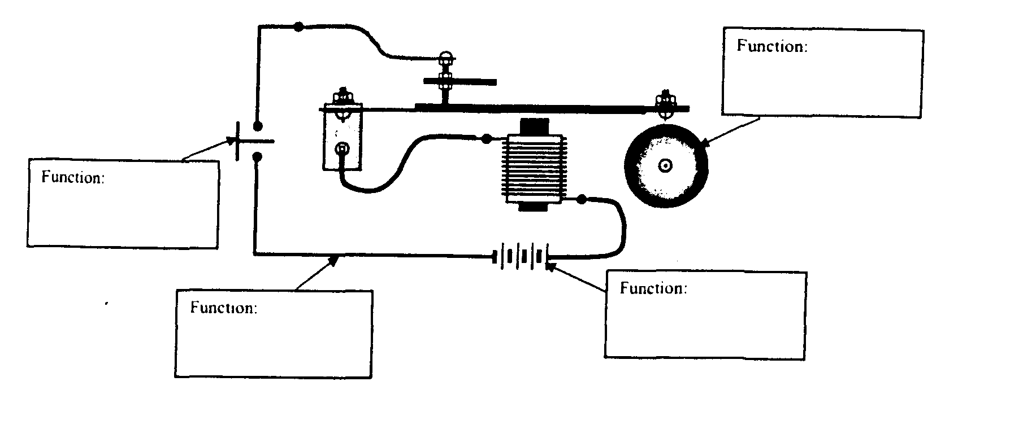

- Give two examples of protective devices.

- What four factors affect the electrical conductivity of a wire? Explain.

- What is the function of a switch?

Ohm’s Law

V=RI R – resistance (measured in ohms - Ω)
V – voltage or potential difference (measured in volts - V)
I – current intensity (measured in amps – A)

- A flashlight has a power source of 3.0 V and operates with a current of 0.20A. What is the resistance in the circuit?

- A circuit has a resistance of 27 Ω and draws a current of 4.4 A. What is the voltage in the circuit?

- An MP3 player uses a current of 2.0 A and has an internal resistance of 3.0 Ω. How many 1.5V batteries are required?

- Your younger brother’s computer game console does not work anymore. You decide to open it up to fix it and notice that the resistor must be replaced. You know that when the console operates with a 9-V battery, the current intensity is 1.2 A. What is the value of the resistor to be replaced?

- Apples are best stored at 0°C with 90% relative humidity and some air circulation. Warmer temperatures will cause apples to age faster and low humidity can cause excessive shriveling. Some apple orchards have refrigerated sheds to store apples that will be distributed at a later date. The refrigeration unit runs on a 240 V generator and requires a current of 15 A. Determine the resistance of the refrigeration unit.

Electrical Circuits
- Draw a circuit diagram to represent each of the situations described.
- a power supply, two resistors (A and B) in series, an ammeter to measure the current in the circuit and a voltmeter to measure the voltage across resistor B.

- a power supply, two light bulbs (A and B) in parallel, a switch that will turn off light bulb B, an ammeter to measure the current in the entire circuit and a voltmeter to measure potential difference across light bulb A.

- A bakery would like to install two ovens that will be powered by a single generator. The criteria for the electrical circuit for the ovens are listed below:
- The ovens must be on the same circuit
- The ovens must be able to work independently from one another
- For safety reasons, the circuit must have a safety switch that stops the operation of both ovens when open.

Draw a circuit diagram to show the two ovens connected to the generator with the safety switch open.

- Certain substances (conductors) allow electricity to travel through them, while others (insulators) do not allow electricity to travel through them. For each substance listed below, identify it as a conductor (C) or an insulator (I).

- Copper ____ 4. Wood ____
- Plastic ____ 5. Silver ____
- Ceramic ____ 6. Rubber ____

- How is alternating current (AC) different from direct current (DC)?

Relationship between power and electrical energy
E = PΔt
P = VI

- A toaster has an electrical power of 970 W. if it used for two and a half minutes, what amount of energy does that represent? Give your answer in joules and kWh.

- The energy consumption for four 40” LCD big screen televisions is listed in the table below as well as the time the televisions were in operation. Based on the information below, determine which model of television consumes the least power.

Model | Electrical energy consumed (kWh) | Time in operation(hours)
1 | 3.6 | 4
2 | 3.2 | 5
3 | 3.0 | 6
4 | 2.4 | 3

- The local bakery uses fresh blueberries to make pies. Two ovens were used to bake the pies;
Oven A: The oven is connected to a 220 V wall outlet that draws a current of 14 A. It took 1 hour to bake the pies in Oven A

Oven B: It took 2 hours to bake the pies in a 2400 W oven. The bakery would like to become more environmentally friendly by consuming less energy.

Which oven should the bakery use in order to be more environmentally friendly? Justify your answer.

Electromagnetism
Magnetic field of a live wire

- Which of the illustrations below, is an accurate representation of the magnetic field of a live wire. Explain your answer.

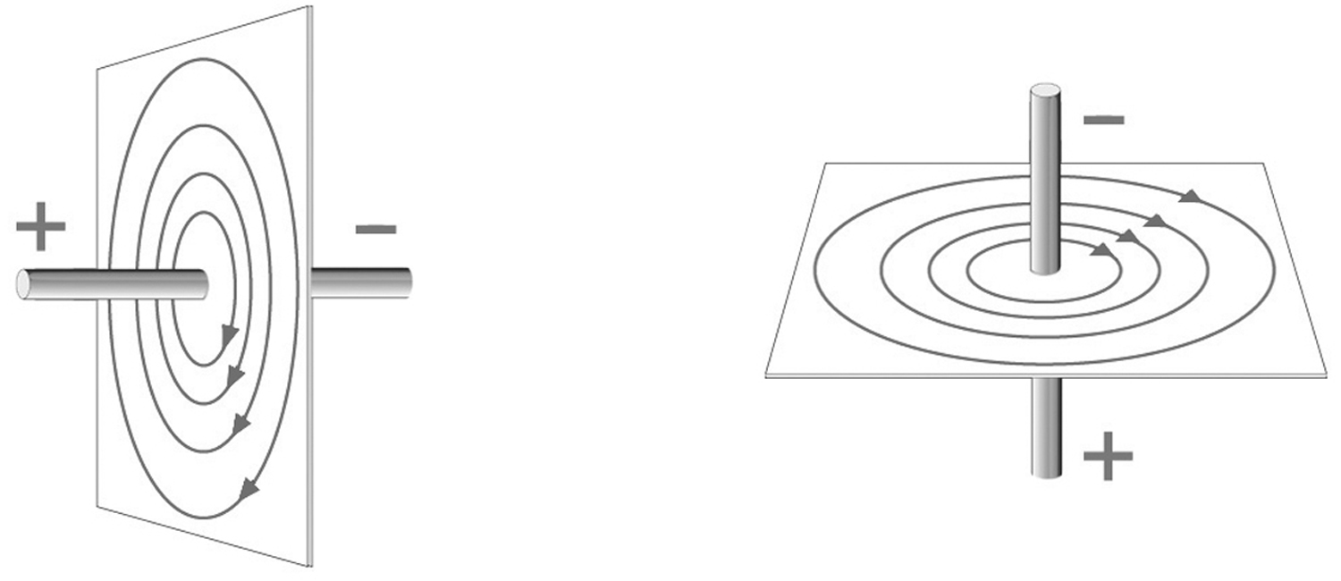
  - b)

Forces of attraction and repulsion

- Draw the direction of the magnetic field around the magnets and determine if an attraction or repulsion will occur.

N S
N S

- The following diagram shows a bar magnet and four compasses. Which compass shows the needle pointing in the correct direction?
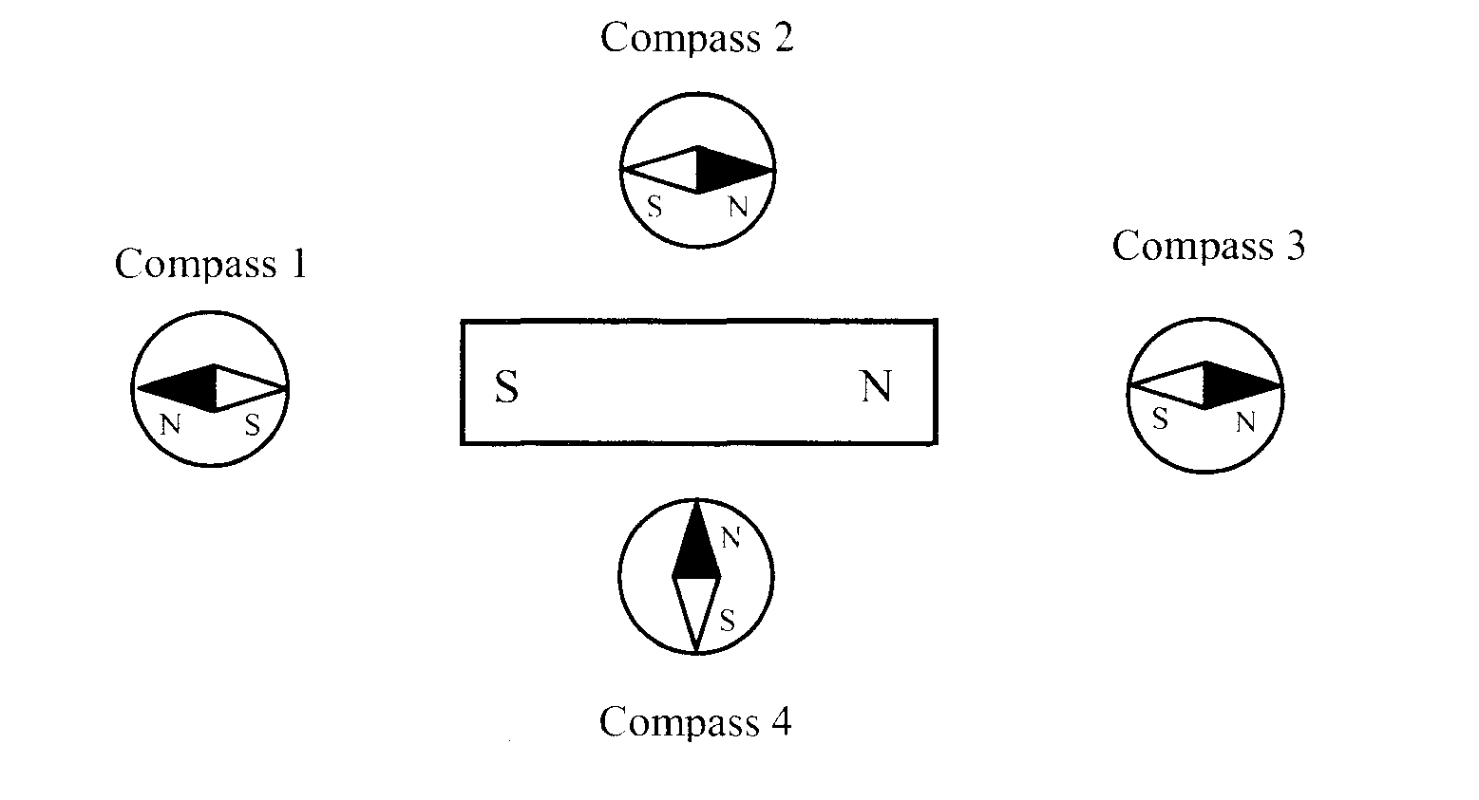
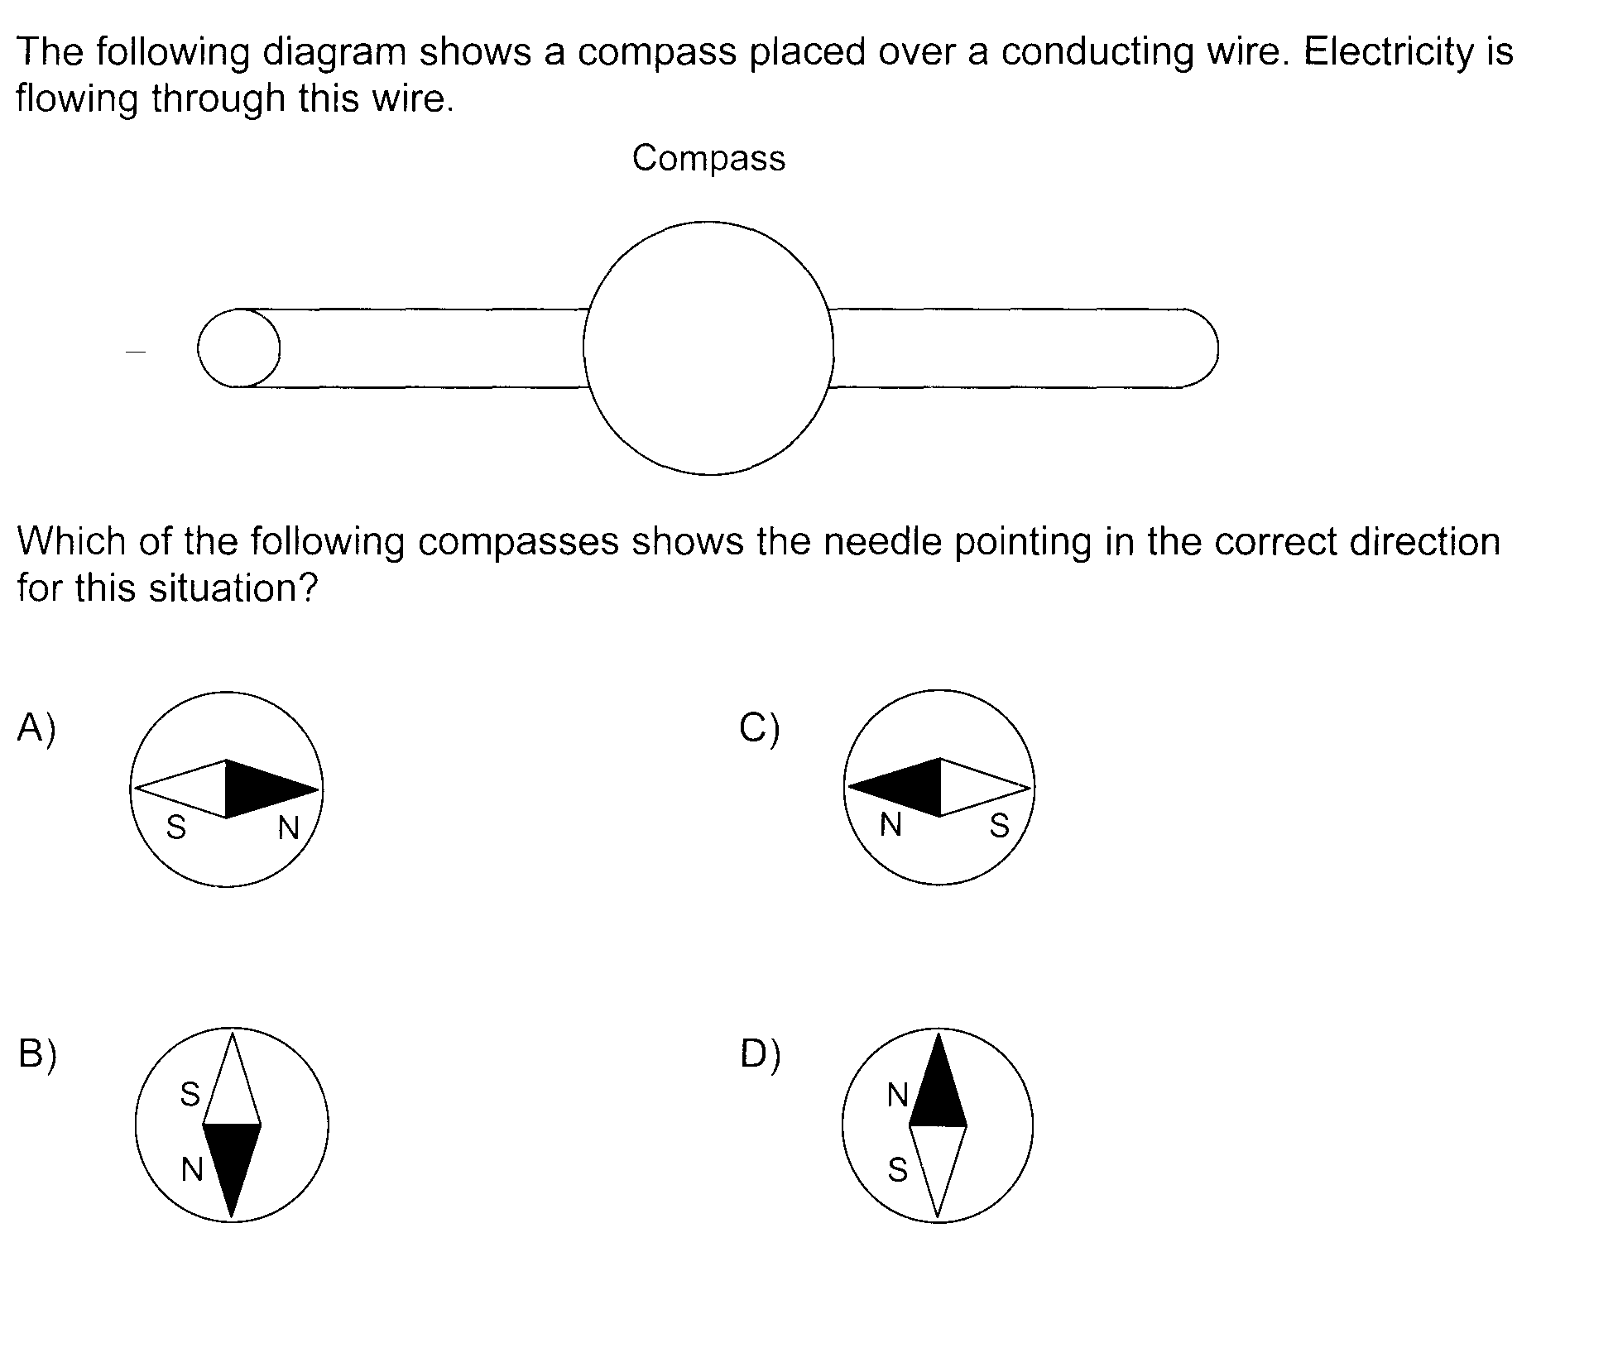

Transformation of Energy

Energy Efficiency

Energy Efficiency = Amount of useful energy x 100
Amount of energy consumed

- A refrigeration unit consumes 16 500 000 J of energy when in use. It uses 9 275 000 J to cool the air in the storage shed. What is the energy efficiency of the refrigeration unit?

- A machine has an energy efficiency of 35 percent. What amount of energy must this machine consume to provide 68 kWh of useful energy?

The Technological World
Mechanical Engineering
Characteristics of mechanical links and guiding controls
- The drawing below indicates three links. Circle the appropriate characteristics of each link. Name the type of guiding between the chassis and the drive shaft.
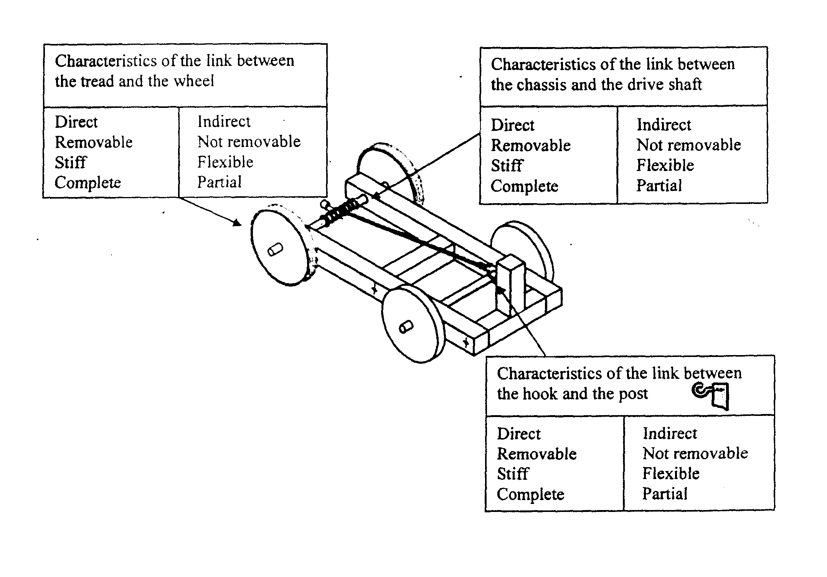
- The following are diagrams of different mechanisms.
Which of these mechanisms makes the driven component rotate in the same direction as the driver component?
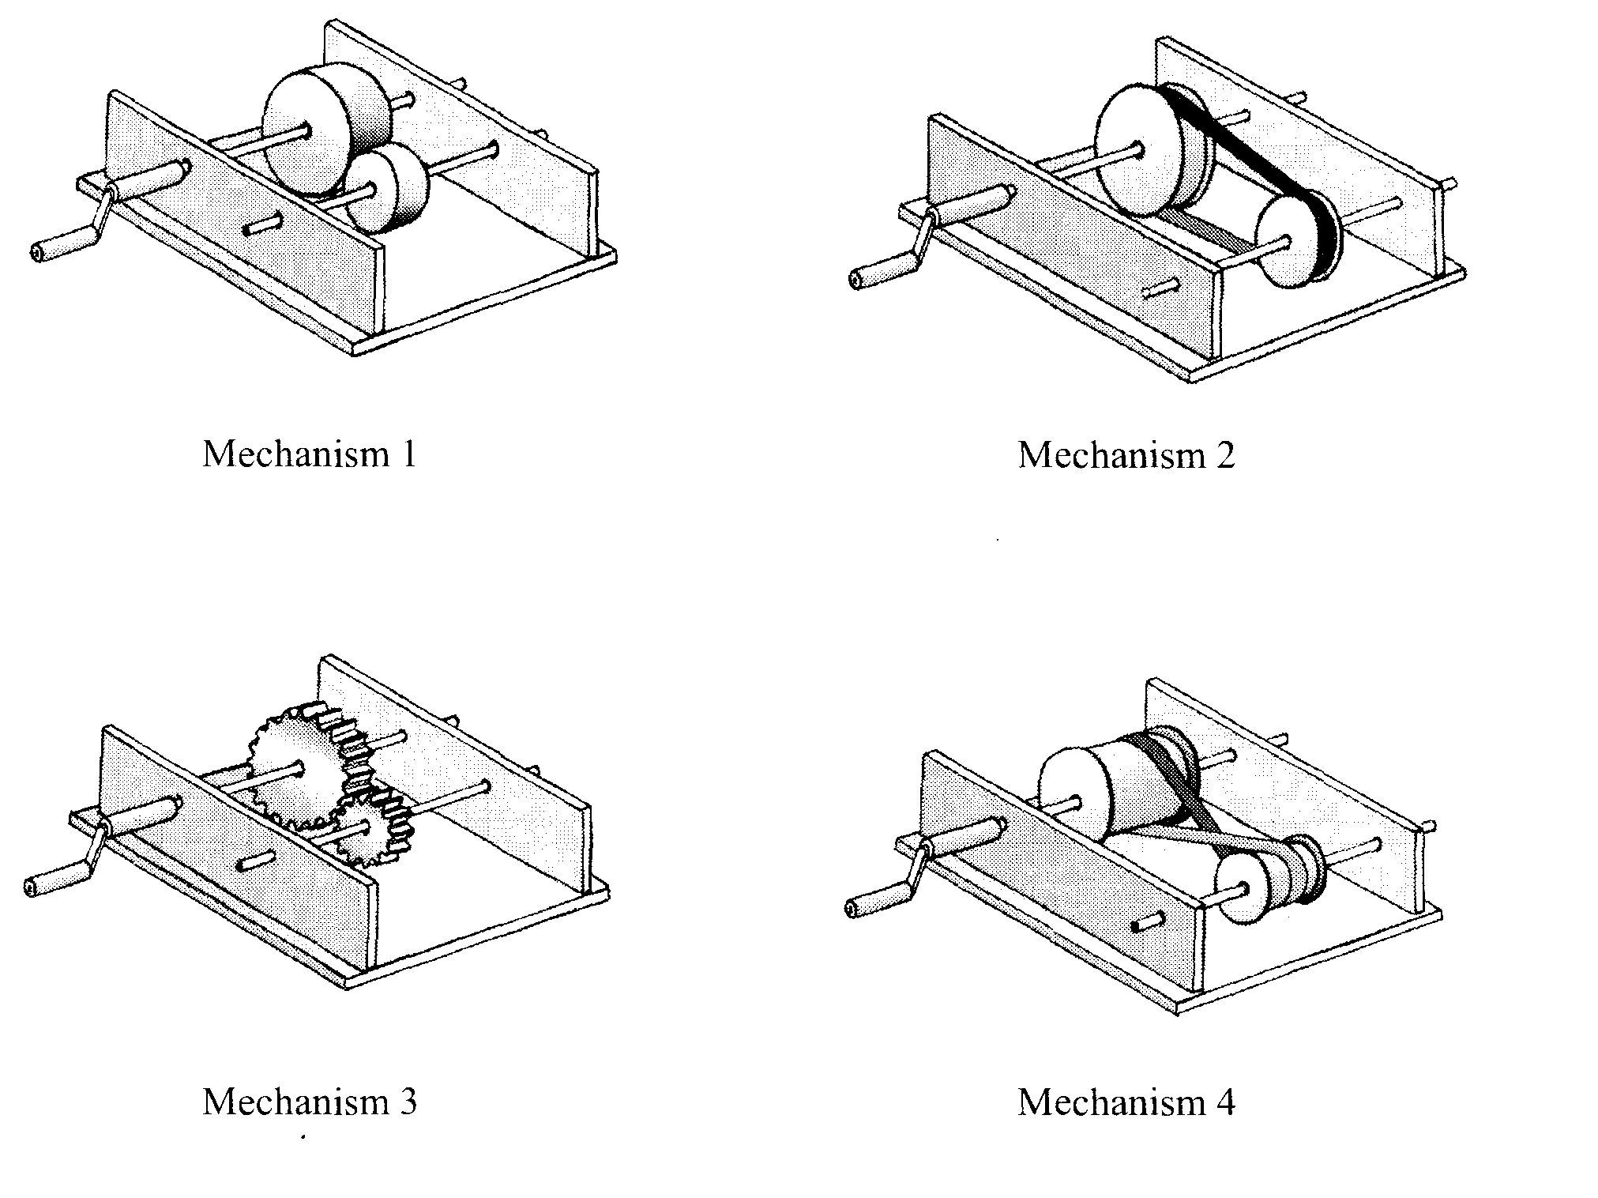
- Identify the motion transmission systems and state whether or not they are reversible.

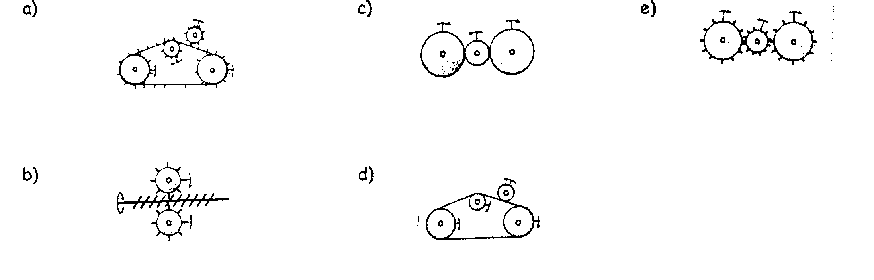
- Identify the following motion transformation systems and state whether or not they are reversible.

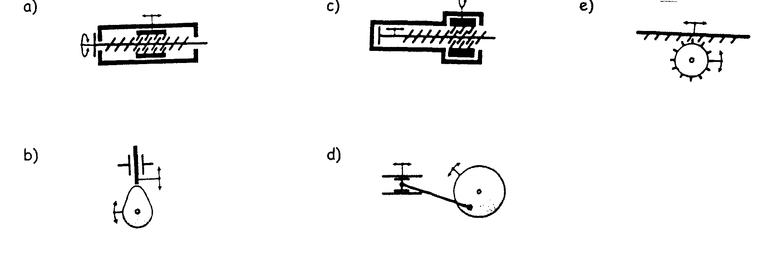
- A diagram of a cider press is shown below.

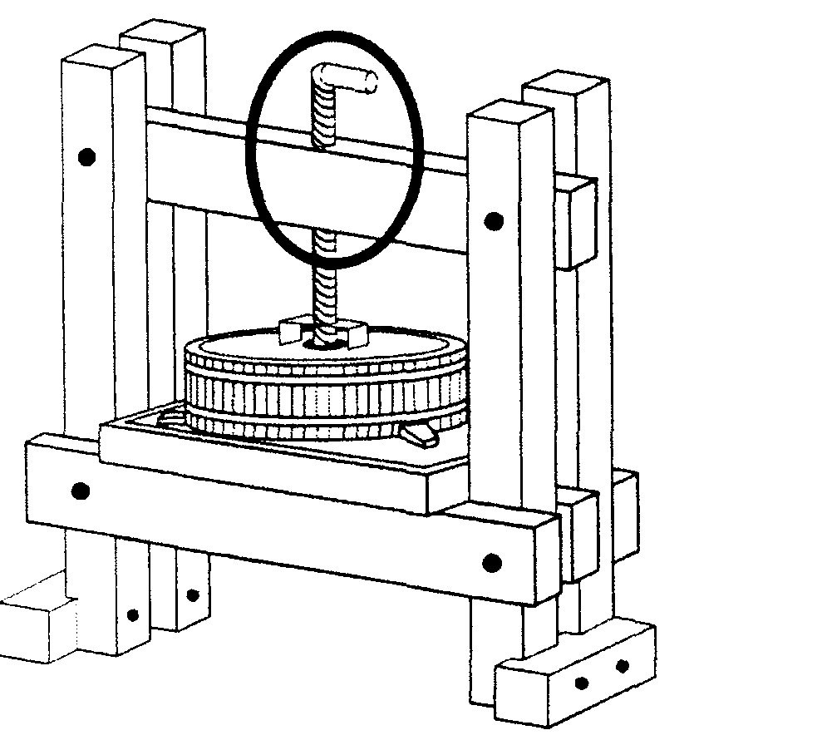

- Identify the type of guiding control circled in the illustration above. Explain your answer.

- Identify and justify the type of motion system in the cider press.
Speed Changes
- Determine the speed ratio for each of the following motion transmission systems and state whether the speed is increased, decreased or not changed.

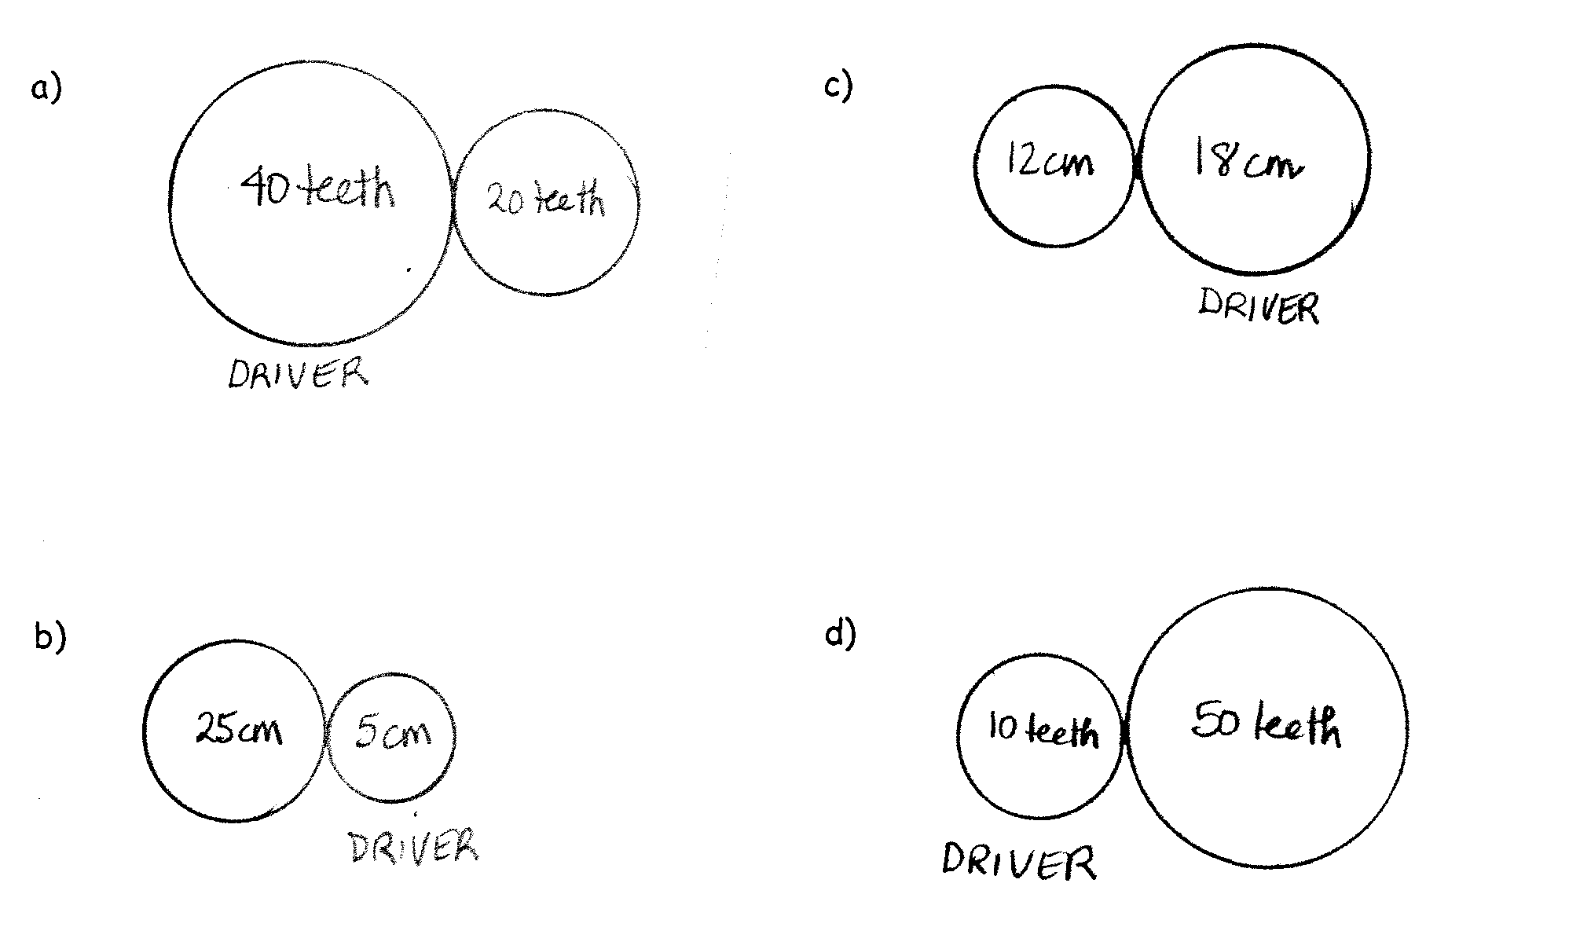

- Bushel baskets used to carry apples are available in wood, plastic or aluminum. Each of these materials has certain advantages and disadvantages. Which of these materials do you think will be best for the production of bushels? Explain the advantages and disadvantages of the chosen material based on the scientific aspects of the material, considering both the mechanical constraints and the material’s properties.

Choice of material: ________________________

Advantages | Disadvantages

- You have considered replacing the broken plate in your doorbell. Some mechanical constraints and properties are listed below. Refer to the diagram of the doorbell and the chart below.
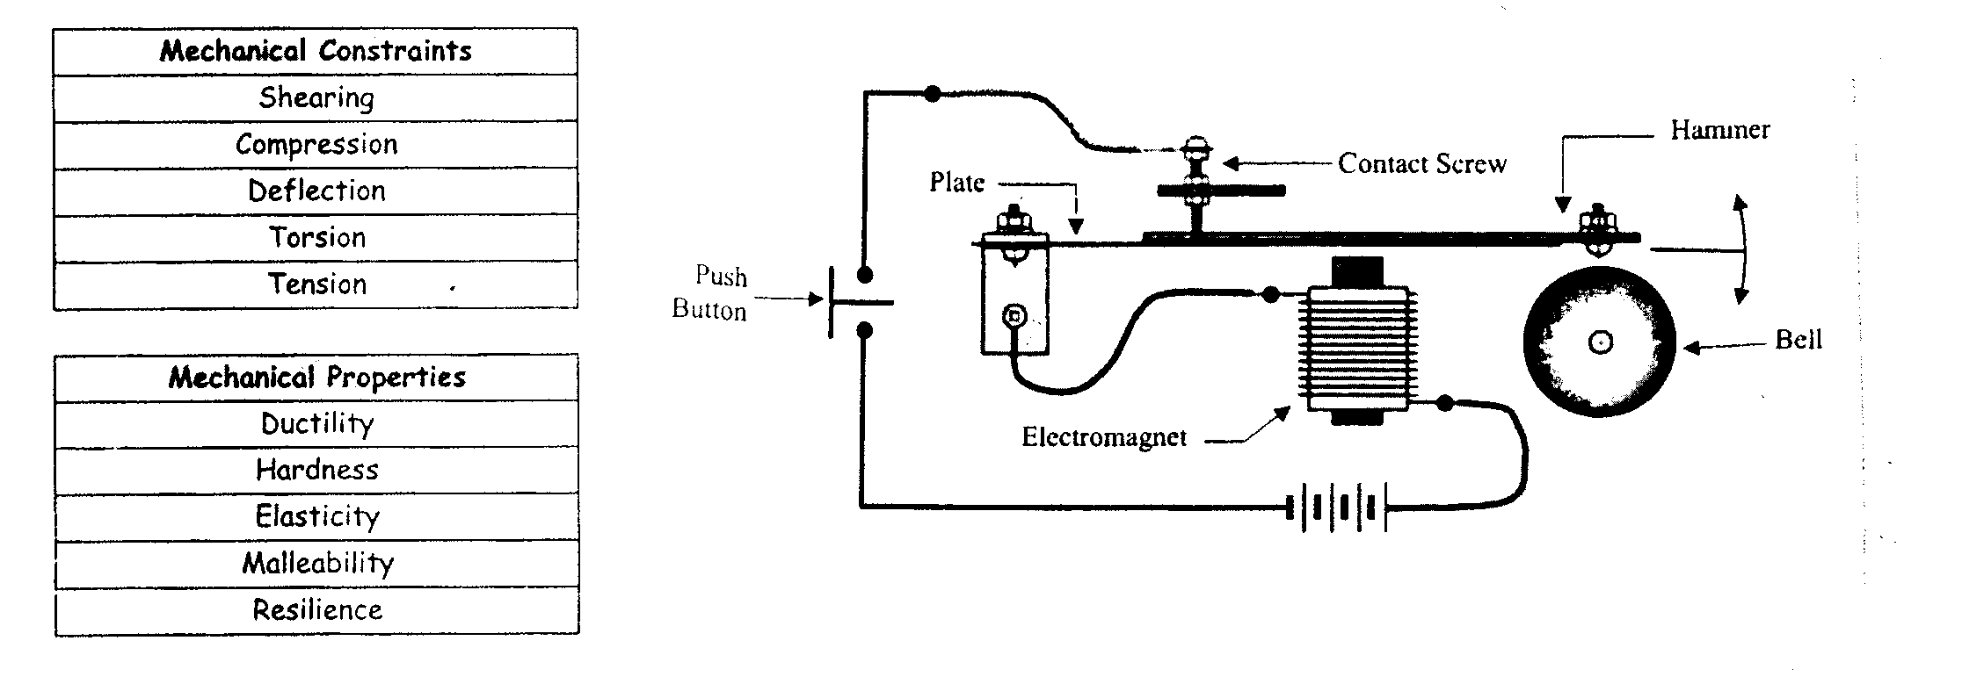
- To what mechanical constraint is the plate subjected when someone rings the doorbell?

- Name a mechanical property that the plate must have. Describe the property.

- What can one do to prevent the corrosion of metals?

Properties of Solutions

Concentration (g/L,%,and ppm) Formula C = m/V

- A pitcher containing 2000 ml of iced tea contains 30 g of sugar. What is the sugar concentration of this solution in grams per liter?

- A variety of orange juice contains 25 g of carbohydrates per 250-mL serving. What is the concentration of carbohydrates in % m/V?

- Which of the following is the most concentrated solution?
Solution | Concentration
1 | 4% m/V
2 | 2 g/100 ml
3 | 5 g/L
4 | 10000mg/1500 ml

- Synthetic fertilizers are used in the garden. We dissolve 0.1 g of fertilizer in 100 ml of water to make a solution. Calculate , in ppm, the concentration of this solution.

- City regulations state that swimming pools must be closed when the concentration of free available residual chlorine in water is less than 0.3 ppm or greater than 5 ppm.
The table below lists the concentrations of free available residual chlorine in water samples taken from four swimming pools. Which two of these pools has water has water that complies with these regulations?

Swimming Pool | Concentration of free available residual chlorine
1 | 0.00002% (m/V)
2 | 0.0004% (m/V)
3 | 0.0004 g/L
4 | 0.0058 g/L

Electrolytes

- Which of the following solution(s) contain electrolytes? Explain your choice.
Solution | Electrical conductivity test
1 | Dim light
2 | Strong light
3 | No light
4 | Strong light

- Two compounds found in fertilizer are potassium oxide, K₂O and phosphorous pentoxide, P₂O_{5.} Which of these two compounds forms an electrolytic solution in water? Justify your answer.

pH Scale

- Identify the substances listed as acidic, basic or neutral.
Substance | pH | Acidic, Basic or Neutral
Egg white | 7.6
Lime water | 12.0
Maple syrup | 6.7
Vinegar | 2.2
Dissolved baking soda | 8.3
Distilled water | 7.0
Peas | 5.8

- Which substance is the strongest base?

- Which substance is the strongest acid?

- Classify the following substances by type of electrolyte (acid, base or salt).
- MgCl₂
- H₂SO₄
- Mg(OH)₂
- HNO₃
- KF

Acid-base neutralization reactions
- Write a word equation, using the words below, to represent a neutralization reaction.
Words to use: Salt Base Acid Water

- One way to neutralize soil is to cover it with lime, (Ca(OH)_{2.} The following table lists the pH values of three different soils.
Soil | pH
A | 8
B | 7
C | 6
Which soil, A, B or C, needs to be covered with lime to neutralize it? Justify your answer.

- Bodies of water tend to die from acid rain that flows into them. A technique called liming is used to neutralize a body of water over the short term.

- What is the effect of liming on the pH of the water in this lake? Does it increase or decrease?

- What would be the final pH value if the water in this lake was completely neutralized?

Energy resources

- An environmental group has asked a company to consider using electricity from renewable energy resources. These energy resources can be found in the lithosphere, hydrosphere and atmosphere. Give an example of an energy resource used to generate electricity for each of the lithosphere, hydrosphere and atmosphere.

Sphere | Energy Resource
Lithosphere
Hydrosphere
Atmosphere
- Fill in the table below.

Source | Layer of the layer where the energy comes from (atmosphere, hydrosphere or lithosphere?)
Hydroelectric energy
Fossil energy
Wind energy
Tidal energy
Geothermal energy
Solar energy

The Earth and Space

Distinction between heat and temperature
- How is heat different from temperature?

Space – Earth-Moon System
- In the diagram below, the doted circle represents the moon’s orbit around the Earth.

- Draw the symbol on the dotted circle to indicate the two (2) points in the orbit where the moon causes the high tides in Ungava Bay. The position of this bay is denoted by the symbol

- Write the letter L on the Earth to indicate the two (2) points where the tides are low at the same time as the tide is high in Ungava Bay.

In the diagram below, the dotted line represents the moon’s orbit around the Earth.

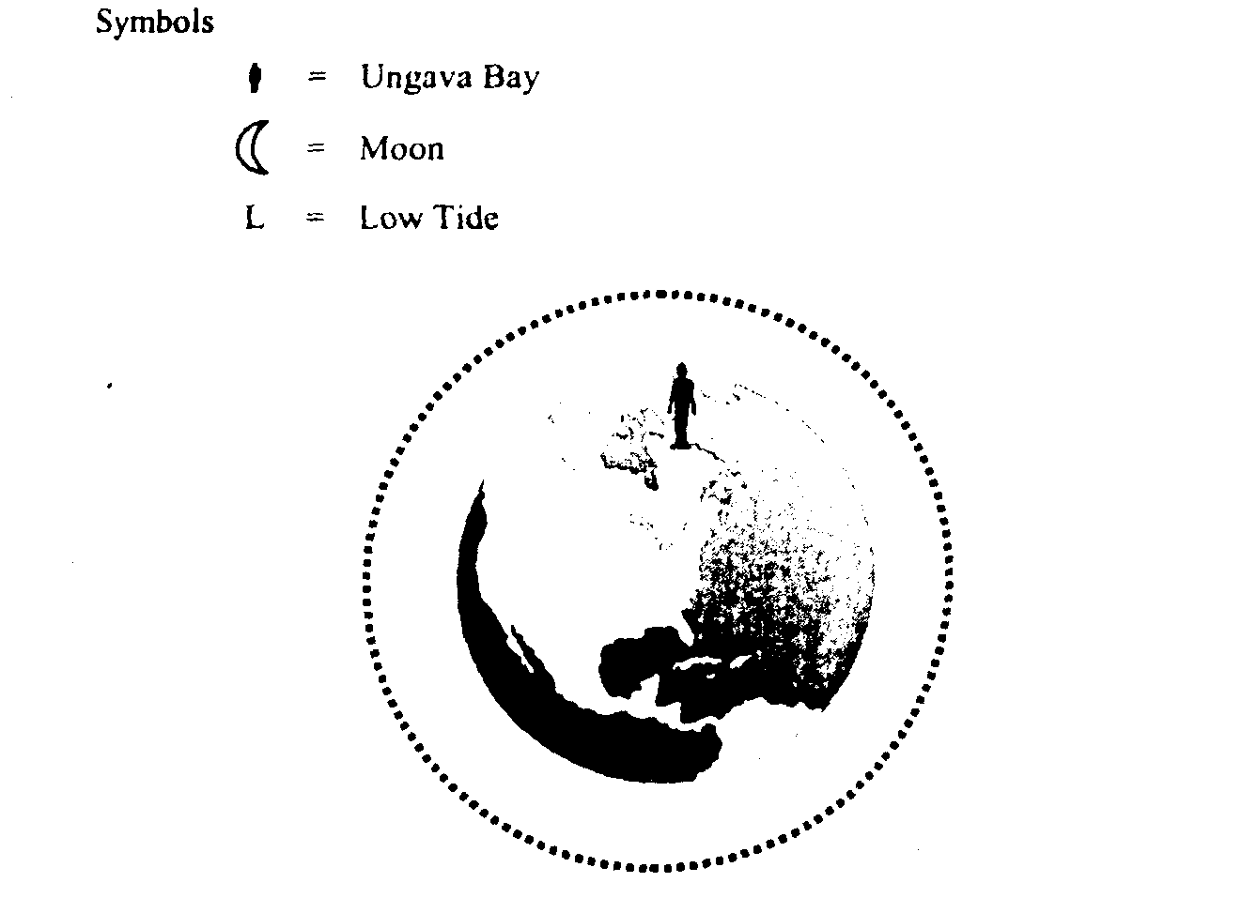

- Indicate whether the following descriptions apply to heat or temperature.
- A fire in the fireplace heats every room in the house._________________________
- Tomorrow, the weather forecast calls for a high of 22 °C. __________________________
- The weather calls for the arrival of a cold air current. __________________________

Hydrosphere
Catchment area

- What is a catchment area (watershed)?

- Name three types of human activity that can cause an impact on the waterways in a catchment area (watershed).

Salinity
- What is salinity?

- Which is denser: distilled water, lake water or ocean water? Explain.

Oceanic circulation
- What causes surface ocean currents?

- What causes subsurface ocean currents?

- Which is denser, cold water or warm water?

- How is oceanic circulation important in regulating global climate?

Glaciers and ice floe
- What is the major difference between an ice floe and a glacier?

- What two effects do the melting of glaciers and ice floes have on Earth?

Atmosphere
Greenhouse Effect

- What is the greenhouse effect?

- Name four greenhouse gases that are found in the Earth’s atmosphere.

- Name two causes of the intensification of the greenhouse effect.

- Describe a consequence of a higher concentration of greenhouse gases in the atmosphere.

Air mass
- An air mass that originated from the Caribbean lies over Quebec, while a fast-moving air mass from the far north is heading down towards it. Explains what happens when the air mass from the far north meets the air mass from the Caribbean. In your explanation, discuss the various phenomena involved.

- The weather forecast for the next week states that a cold Northeast wind has moved off the coast of New Brunswick, originating from the North Pole. Over the next few days, an air mass will be moving in off the coast of Jamaica towards the Monteregie region of Quebec. Explain what will happen when the two air masses meet. Your explanation must include the various phenomena involved.

Atmospheric circulation
- What causes winds to blow?

- Cyclist A leaves Montreal for Quebec while at the same time, Cyclist B of equal ability leaves Quebec from Montreal. If a high pressure system is hanging over Quebec, and a low pressure system is hanging over Montreal, which cyclist A or B will be first to arrive at his destination. Explain your answer.

Cyclone and anticyclone
- What happens to the density of air as it is warmed up in the atmosphere?Explain.

- What happens to the density of air as it is cooled in the atmosphere?Explain.

- What do you call an area of atmospheric circulation surrounding an area of high pressure?

- What do you call an area of atmospheric circulation surrounding an area of low pressure?

- What type of weather do you expect in an area of high presure. Explain.

- What type of weather do you expect in an area of low pressure? Explain.

Lithosphere
Minerals

- What is the difference between a mineral and an ore?

- Look at the illustration opposite.

Name each of the soil layers.

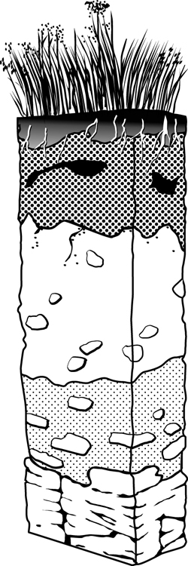

- At the student horticulturists’ market, they are selling 25-L bags of soil labelled “Garden soil.” Which soil layer is removed to fill these bags? Explain your answer.

- What is permafrost?

- What is a consequence of a rise in temperature in the permafrost?

Carbon cycle

- Fill in the blanks with the following words: Respiration, photosynthesis, ingestion, decomposition of wastes, the formation of fossil fuels, decomposers, shells, skeletons.
- Plants capture carbon dioxide and transform it into glucose by the process called _____________________________.
- Living organisms return the carbon they have ingested to the atmosphere by breathing out carbon dioxide in a process called _____________________________________
- The rest of the carbon from living organisms is eliminated as waste and broken down by ________________________________.
- Carbon dioxide dissolved in water reacts with water and then with calcium to become calcium carbonate which gradually forms the _____________________ and ______________________ of marine organisms.
- The carbon in dead animals sometimes changes into ____________________ __________________ such as coal, gas or oil in a process that takes millions of years.
- Animals eat plants to get the carbon they need to grow. _________________________.

Nitrogen cycle

- Fill in the blanks with the following words: Nitrification, proteins, denitrification, decomposition of wastes, nitrogen absorption, nitrogen fixation, nitrates, consumers, decomposers.

- Nitrogen is essential in the formation of _______________ and DNA.

- Since atmospheric nitrogen cannot be used by living organisms, bacteria first change it into ammonia in a process called ____________________________________.

- Bacteria also oxidize ammonium to form nitrites in a process called _____________________.

- Other bacteria oxidize nitrites into _____________________.

- _______________________ get the nitrogen they need by eating producers.

- ___________________ break down the nitrogen-containing substances in plant and animal waste. They produce ammonia which dissolves and forms ammonium.

- Certain bacteria convert nitrates into atmospheric nitrogen in a process called _________________.

Climate zone
Factors that influence the distribution of biomes
- What are biomes?

Terrestrial Biomes
- Which terrestrial biome has the most biodiversity? Explain.

- Which terrestrial biome has the least biodiversity? Explain.

- Which terrestrial biome is the most at risk from climate change? Explain.
Marine Biomes
- How is a freshwater biome different than a marine biome?

- Name three different types of freshwater biomes.

- Name three different types of marine biomes.

The Living World
Study of populations

Population Size and population density

- You want to find out the size of a daisy population in a field of 10 000m² so you count the average number of daisies in two-square meter (2m²) quadrants. You determine that there is an average of five daisies per quadrant. What is the size of the population of daisies?

- In a 500 000 km² African wildlife park, there are 20 000 giraffes. What is the density of giraffes per km?

- Last year, 24 deer were captured and marked in an effort to determine the size of the deer population living in the park. This year, in this same rectangular area measuring 12.85 km by 3.5 km, a second group of deer was captured and of the 27 deer captured, 18 were already marked. Calculate the deer population density in this park.

Population Distribution
- Individuals that make up a population are distributed in different ways within the space they inhabit. Choose whether the following show clumped distribution, uniform distribution or random distribution.
- Many fish move around their habitats in schools. __________________________________
- Northern gannets give each other minimal territory by spacing their nests at regular intervals. ____________________________________
- The balsam poplar that grows in Québec is a tree that can reach a height of 35 m. It can reproduce asexually, with the result that isolated stands of balsam poplars are often found in the forest. ________________________

Biological Cycles
- Associate each of the following with an increase or a decrease in the size of a Québec population. Support your answer by citing factors that affect population size.

- The black bear population in Québec experiences a 50-birth boom. At the same time 60 bears cross the border into Ontario.

- Fish farmers stock a river with salmon fry.

- Every spring, Canada geese return to Lac Tranquille.

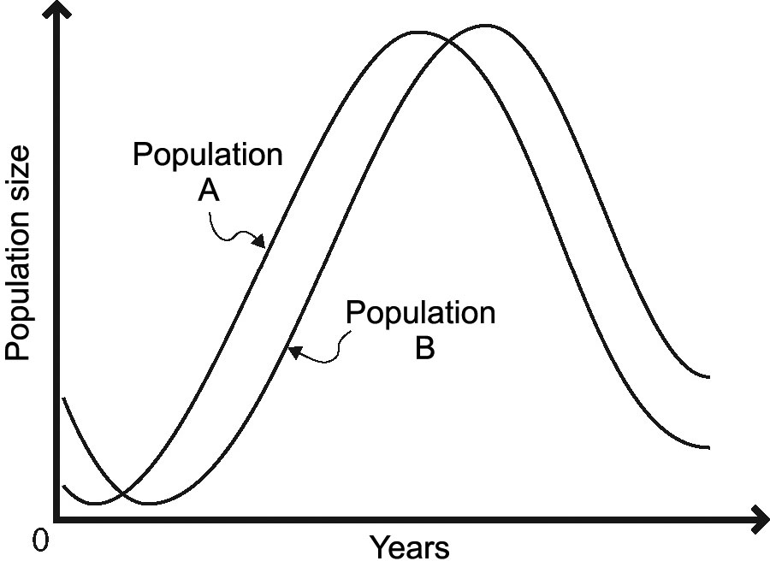
- The graph opposite represents the biological
cycles of two animal populations in a predator-
prey relationship.
- Which population is the prey?

- Which population is the predator?

- Explain how you arrived at your answers to questions a) and b).

Availability of Resources
- This year, the deer population has fallen considerably. First, the saplings that deer eat were ravaged by disease. Weakened by lack of food, the deer became easy prey for wolves. To make matters worse, heavy snowfall at the end of the year made finding food on the ground more difficult. Name one abiotic factor and two biotic factors that led to a decline in the deer population.

Dynamics of communities
Biodiversity
- The Addo Elephant National Park serves as a refuge for elephants, buffalos, antelopes and birds. If the Addo park sheltered 30 percent elephants. 30 percent buffalo, 20 percent antelopes and 20 percent birds and the neighboring park sheltered 60 percent giraffes, 30 percent elephants and 10 percent birds, which of the two parks would have the greatest biodiversity with respect to these species? Explain your answer.

Disturbances
- Choose whether the following describes a natural or a human disturbance to an ecosystem
- The freezing of a lake in the winter ________________________
- A volcanic eruption _____________________
- An oil spill at sea ________________________
- A tree struck by lightning__________________________
- Mining for copper _________________________
- A heat wave in the summer _________________________
Dynamics of Ecosystems
Trophic Relationships

- Refer to the following food web and answer the questions associated with it.
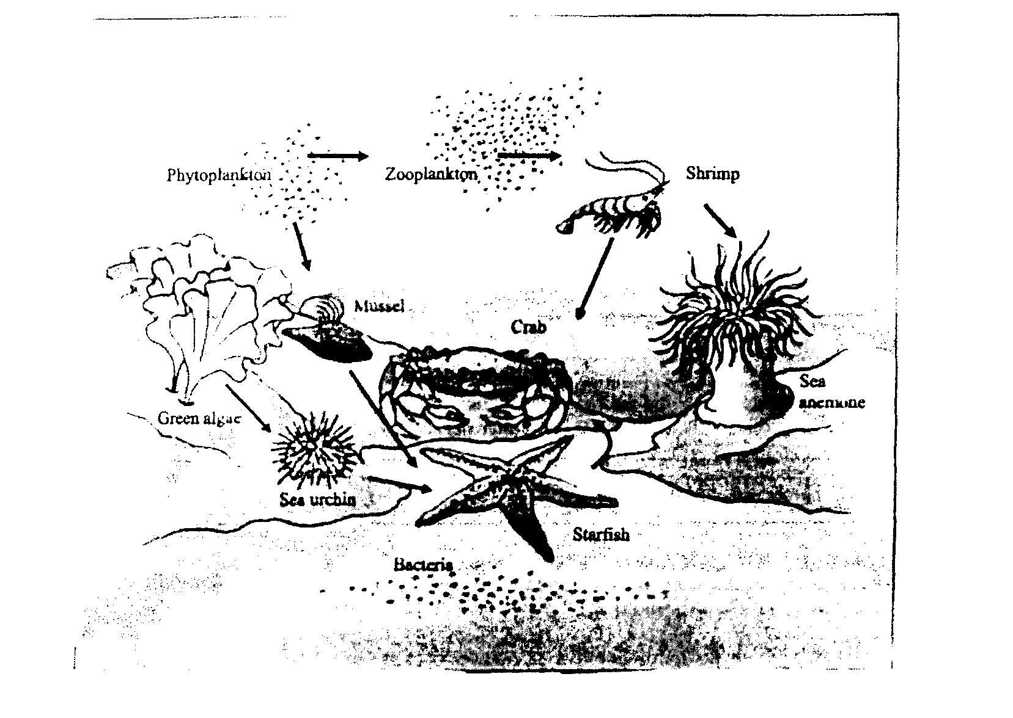
Indicate the organisms from the food web that belong to the trophic levels indicated.

Producers | First–level Consumers | Second-level Consumers | Third-level Consumers | Decomposers
- Refer to the following food web and answer the questions associated with it.
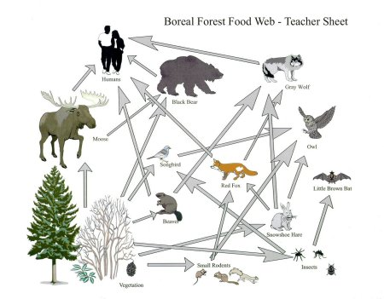

- Which populations, the songbird or the snowshoe hare, would be the most affected by deforestation. Explain.

- Which of the following populations would have a greater effect on primary productivity in the ecosystem, the extinction of the red fox or the extinction of the brown bat? Explain.

Primary Productivity
- The Earth contains many biomes, including the arctic tundra, the tropical forest, the desert, the boreal forest and grasslands.
- Which of these biomes has the greatest primary productivity? Explain.

- Name four factors that affect primary productivity that make this biome the most productive.
- An ecosystem is composed of water, trees, beavers, ducks, aquatic plants and soil. Which of these elements are not calculated as part of the biomass? Explain your answer.

Material and Energy Flow
- A researcher has determined that the temperate forest receives 2000 J of energy from solar radiation within a specific period of time. The forest is home to a large variety of plants and animals, forming a complex trophic network. Use this information to answer the following questions.
- How do the living organisms at the various trophic levels obtain the energy they need?

- What happens to the 2000 J of solar energy as it is passed along the food chain? Explain your answer.

Chemical Recycling
- What is the role of decomposers in the process of chemical recycling?

- What is the role of producers in the process of chemical recycling?

